# Transcriptome-Based Prediction of Methylphenidate Efficacy: Implications for Precision Medicine in Psychiatric Disorders

# Exploring the Genetic Landscape of Methylphenidate Response: Insights into Treatment Optimization

Muhammad Elsadany1,2, Taylor R. Thomas1,2, Lucas G. Casten1,2, Jacob J. Michaelson1,2,3,4,5 *

**1** Department of Psychiatry, University of Iowa, Iowa City, IA

**2** Interdisciplinary Graduate Program in Genetics, University of Iowa, Iowa City, IA

**3** Department of Communication Sciences & Disorders, University of Iowa, Iowa City, IA

**4** Iowa Neuroscience Institute, University of Iowa, Iowa City, IA

**5** Department of Biomedical Engineering, University of Iowa, Iowa City, IA

**\*** jacob-michaelson@uiowa.edu

# 1. Abstract

**Background:** Attention-deficit/hyperactivity disorder (ADHD) is a common neuropsychiatric disorder with a complex etiology involving both genetic and environmental factors. Stimulant medications, such as methylphenidate and amphetamines, are widely used as a primary treatment for ADHD. However, individual responses to these medications vary, and the genetic basis of medication response remains largely unexplored. Additionally, the role of cognitive abilities in shaping medication response is not well understood.

**Methods:** In this study, we investigated the correlation between polygenic scores (PGS) for cognitive traits (gFactor) and ADHD with the usage and effectiveness of stimulant/non-stimulant medications in two independent cohorts, SPARK and ABCD. We also developed a novel approach based on transcriptome imputation to predict drug response using genetic profiles. The predicted response was then correlated with PGS for cognitive traits and ADHD.

**Results:** We observed a significant positive correlation between ADHD PGS and the usage of stimulant medications, indicating that individuals with higher genetic risk for ADHD are more likely to be prescribed these medications. Conversely, individuals with higher cognitive gFactor PGS showed a reduction in behavioral problems and ADHD symptoms when taking stimulant medications. Non-stimulant medications, such as guanfacine, exhibited a different pattern, suggesting potential benefits for individuals with higher ADHD PGS. Furthermore, our transcriptome imputation-based prediction revealed a significant positive correlation between predicted drug response and cognitive gFactor PGS, suggesting that individuals with higher genetic predisposition for better cognitive functioning may have a more favorable response to methylphenidate treatment.

**Conclusion:** This comprehensive study provides valuable insights into the genetic basis of medication usage and response in ADHD. Our findings highlight the potential of genetic information in guiding personalized treatment strategies and offer promising prospects for advancing personalized medicine in ADHD.

**Keywords:** ADHD, methylphenidate response, genetic profiles, transcriptomic imputation, polygenic scores, personalized medicine, stimulants.

# 2. Introduction

Although progress in human genetics has drastically accelerated in the decades since the Human Genome Project, the current impact of genomic data on treatments for disease is limited. Still, individual genotype profiles have been known to be a major player in differentiating response to different pharmacological compounds (Dunnenberger et al., 2015; Relling & Evans, 2015). The field of pharmacogenomics is rapidly growing, with the aim of providing personalized interventions for patients by uncovering the genetic basis of inter-individual variability in drug response. However, currently available pharmacogenomic services are limited in their ascertainment of genetic variation, with an emphasis on drug metabolism, known drug targets, and known mechanisms of action. This approach may result in blind spots relating to off-target effects and additional/alternative therapeutic mechanisms. A more comprehensive understanding of drug response could provide recommendations that maximize therapeutic effect while minimizing side effects.

Attention deficit hyperactivity disorder (ADHD) is a prevalent condition, affecting approximately 6 million (9.8%) of US children aged 3–17 years ever diagnosed with ADHD (using CDC data from 2016-2019), with significant variations across different populations and cultures (CDC, 2022). The etiology of ADHD is complex, involving a combination of genetic, environmental, and neurobiological factors, and its diagnosis often occurs alongside comorbid conditions such as oppositional defiant disorder (ODD), conduct disorder (CD), and learning disabilities (LD) (Pliszka, 1998). While several treatment options are available, methylphenidate (MPH) remains one of the most prescribed medications due to its efficacy in alleviating ADHD symptoms. However, predicting individual response to methylphenidate treatment poses a challenge, necessitating a comprehensive exploration of various factors that influence treatment outcomes. This paper provides an updated view of ADHD treatment, specifically using MPH, in children, its comorbidities, and contemporary perspectives on predicting response to MPH, integrating relevant research and current statistics.

Individuals with ADHD often require pharmacological interventions to manage their symptoms and improve their daily functioning (American-Academy-of-Pediatrics, 2022). Stimulants have shown to be efficacious in treating ADHD symptoms, including short attention span, impulsivity, and hyperactivity. Approximately 70% of adults and 70-80% of children experience an improvement in their ADHD symptoms when using these medications (Advokat & Scheithauer, 2013). Notably, stimulants have been observed to reduce interruptive behavior, fidgeting, and other hyperactive manifestations. Methylphenidate (MPH), a commonly prescribed medication for ADHD, has shown efficacy in enhancing attention and reducing hyperactivity in many individuals (Storebo et al., 2018). However, there is significant variability in individual drug response, with some individuals experiencing substantial benefits while others show limited improvement or even adverse effects (Cortese et al., 2018; de Faria et al., 2022; Kimko et al., 1999). The effectiveness of methylphenidate remains a subject of debate. While some studies suggest that short-term use of methylphenidate may improve academic performance in ADHD students, others suggest that it does not lead to great improvements on an academic performance level and the overall evidence lacks consensus (de Faria et al., 2022). Thus, there is a need for understanding the factors that contribute to this variability in drug response, which is crucial for optimizing treatment strategies and achieving personalized medicine approaches.

Traditionally, drug response assessments have relied on subjective reporting from patients, parents, or caregivers (Chang et al., 2021; Grazioli et al., 2021; Vertessen et al., 2023). Although valuable, these assessments are inherently subjective and can be influenced by various factors, including placebo effects and biases. Objective measures, such as neuroimaging or behavioral tasks, have also been employed to evaluate drug effectiveness. However, these measures often require the patient to be on medication for several weeks before any measurable changes can be observed, making them time-consuming and less suitable for rapid treatment optimization.

To address these limitations, there is a growing interest in leveraging genetic information to predict drug response. Genetic factors play a significant role in individual variability in drug metabolism, receptor binding, and overall pharmacodynamics (Belle & Singh, 2008; Evans & Johnson, 2001; Ingelman-Sundberg et al., 2018; Roden et al., 2011; Scharfe et al., 2017; Weinshilboum, 2003; Wilke & Dolan, 2011). Polygenic scores (PGS) derived from genome-wide association studies (GWAS) have been used to capture the genetic contribution to complex traits and diseases. By incorporating PGS into predictive models, it is possible to estimate an individual's likelihood of responding favorably to a specific medication.

In this study, we aimed to develop a method for predicting drug response based on genetic profiles and apply it to methylphenidate. We hypothesized that by leveraging genetic information and transcriptomic profiles, we could identify individuals who are more likely to respond positively to methylphenidate, thereby enabling personalized treatment strategies. Our approach involved imputing transcriptomic profiles for excitatory neurons based on expression quantitative trait loci (eQTL) weights and comparing them to the methylphenidate transcriptomic signature derived from the Connectivity Map (CMap) database.

To study the effectiveness of MPH treatment, we utilized data from the SPARK[1] and ABCD[2] cohorts. The SPARK cohort provided subjective reports on methylphenidate effectiveness and social communication abilities, while the ABCD cohort provided objective measures of attention and cognitive performance. By comparing the computed PGS and our predicted drug response with the objective measures, we aimed to establish the utility of our approach in predicting clinical outcomes and identifying individuals who are more likely to benefit from MPH treatment.

The findings from this study have the potential to significantly impact clinical practice by enabling more targeted and individualized treatment strategies for neurodevelopmental disorders. By accurately predicting drug response, clinicians can optimize medication choices and dosages, reducing the trial-and-error approach and minimizing potential side effects. Moreover, our approach offers a valuable framework for exploring the genetic underpinnings of drug response, contributing to the broader understanding of the pharmacogenetics of neurodevelopmental disorders.

In summary, this study aimed to study and utilize genetic data for predicting methylphenidate response. By incorporating transcriptomic imputation and comparing it to the drug signature, we sought to provide an objective and personalized approach to drug response prediction.

# 3. Results

## 3.1. Correlation between PGS and taking stimulants and other ADHD medications.

In this study, we investigated the relationship between polygenic scores (PGS) for cognitive traits, primarily focusing on gFactor, and attention-deficit/hyperactivity disorder (ADHD) medication usage in two distinct cohorts: the SPARK and ABCD cohorts. To explore this correlation, we computed PGS for cognitive gFactor and ADHD for each participant and examined their medical history to determine the usage of stimulant medications. In the SPARK cohort (Figure 1-A), our analysis revealed a significant positive correlation (FDR < 0.05) between ADHD PGS and the usage of widely prescribed stimulant medications, such as methylphenidate and amphetamines, commonly used for treating ADHD. Similarly, in the ABCD cohort (Figure 1-B), we observed a significant positive correlation between ADHD PGS and the utilization of various medications, including Adderall, Focalin, Vyvanse, Methylphenidate, Concerta, and Ritalin.

Of particular interest, we also identified a significant negative correlation between cognitive PGS and the usage of specific medications within the ABCD cohort. Specifically, medications such as Adderall, Vyvanse, Clonidine, and Methylphenidate demonstrated a negative association with cognitive PGS. These findings suggest that individuals with a genetic predisposition towards higher cognitive abilities may be less likely to be prescribed certain medications commonly used to manage ADHD symptoms.

Our results highlight the potential influence of genetic factors in medication choices for individuals with ADHD, particularly regarding stimulant medications. Furthermore, the observed negative correlation between cognitive PGS and specific medication usage in the ABCD cohort adds an intriguing dimension to the complexity of medication response in individuals with ADHD.

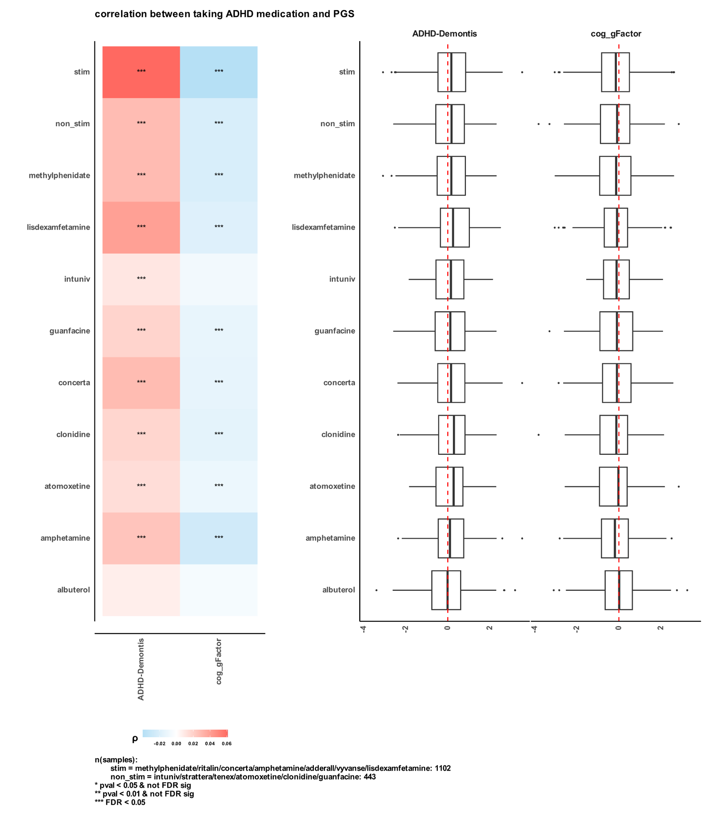

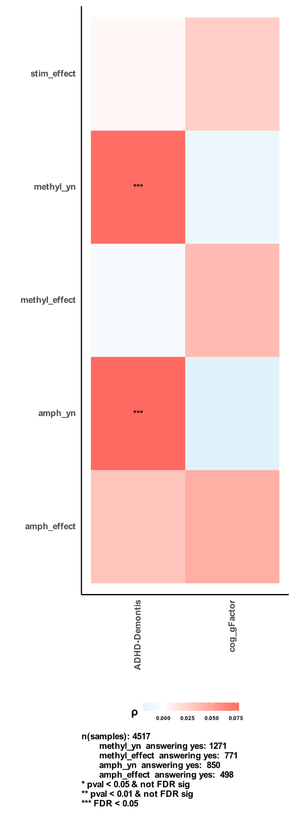

3.2. Correlation between PGS and change in behavior with and without taking ADHD medication.

We delved into understanding how the usage of ADHD medication influences participants' behavior, particularly focusing on the change (delta) in behavior associated with taking the medication. By computing deltas for various measures based on the status of taking the drug, we aimed to uncover potential associations with both ADHD and cognitive gFactor polygenic scores (PGS). We analyzed the deltas separately for two major drug categories: stimulants and non-stimulants (Figure 2).

While the correlations between PGS and deltas of Child Behavior Checklist (CBCL) for stimulants did not reach significance (nominal p-value > 0.05), they exhibited a distinctive pattern that contrasts with non-stimulants. Specifically, participants with high ADHD PGS and taking stimulants displayed higher ADHD symptoms and other behavioral problems, as indicated in the CBCL data. In contrast, individuals with high cognitive gFactor PGS demonstrated a reduction in behavioral problems and ADHD symptoms. These observations suggest that participants with a higher genetic predisposition for ADHD and taking stimulants may experience a greater burden of behavioral difficulties compared to their baseline condition without medication.

Significantly, we observed a negative correlation (nominal p-value < 0.01) between ADHD PGS and ADHD symptoms measured by CBCL for non-stimulant medications. This finding implies that participants with higher ADHD PGS experienced improvement in ADHD symptoms when using non-stimulant medications. Similarly, the reduction in the attention syndromic subscale from CBCL also corroborated this outcome. Conversely, participants with higher cognitive gFactor PGS and taking non-stimulants demonstrated a positive correlation with ADHD symptoms, albeit not reaching significance. This indicates that individuals with lower cognitive gFactor PGS might benefit more from non-stimulant medications in terms of alleviating ADHD symptoms.

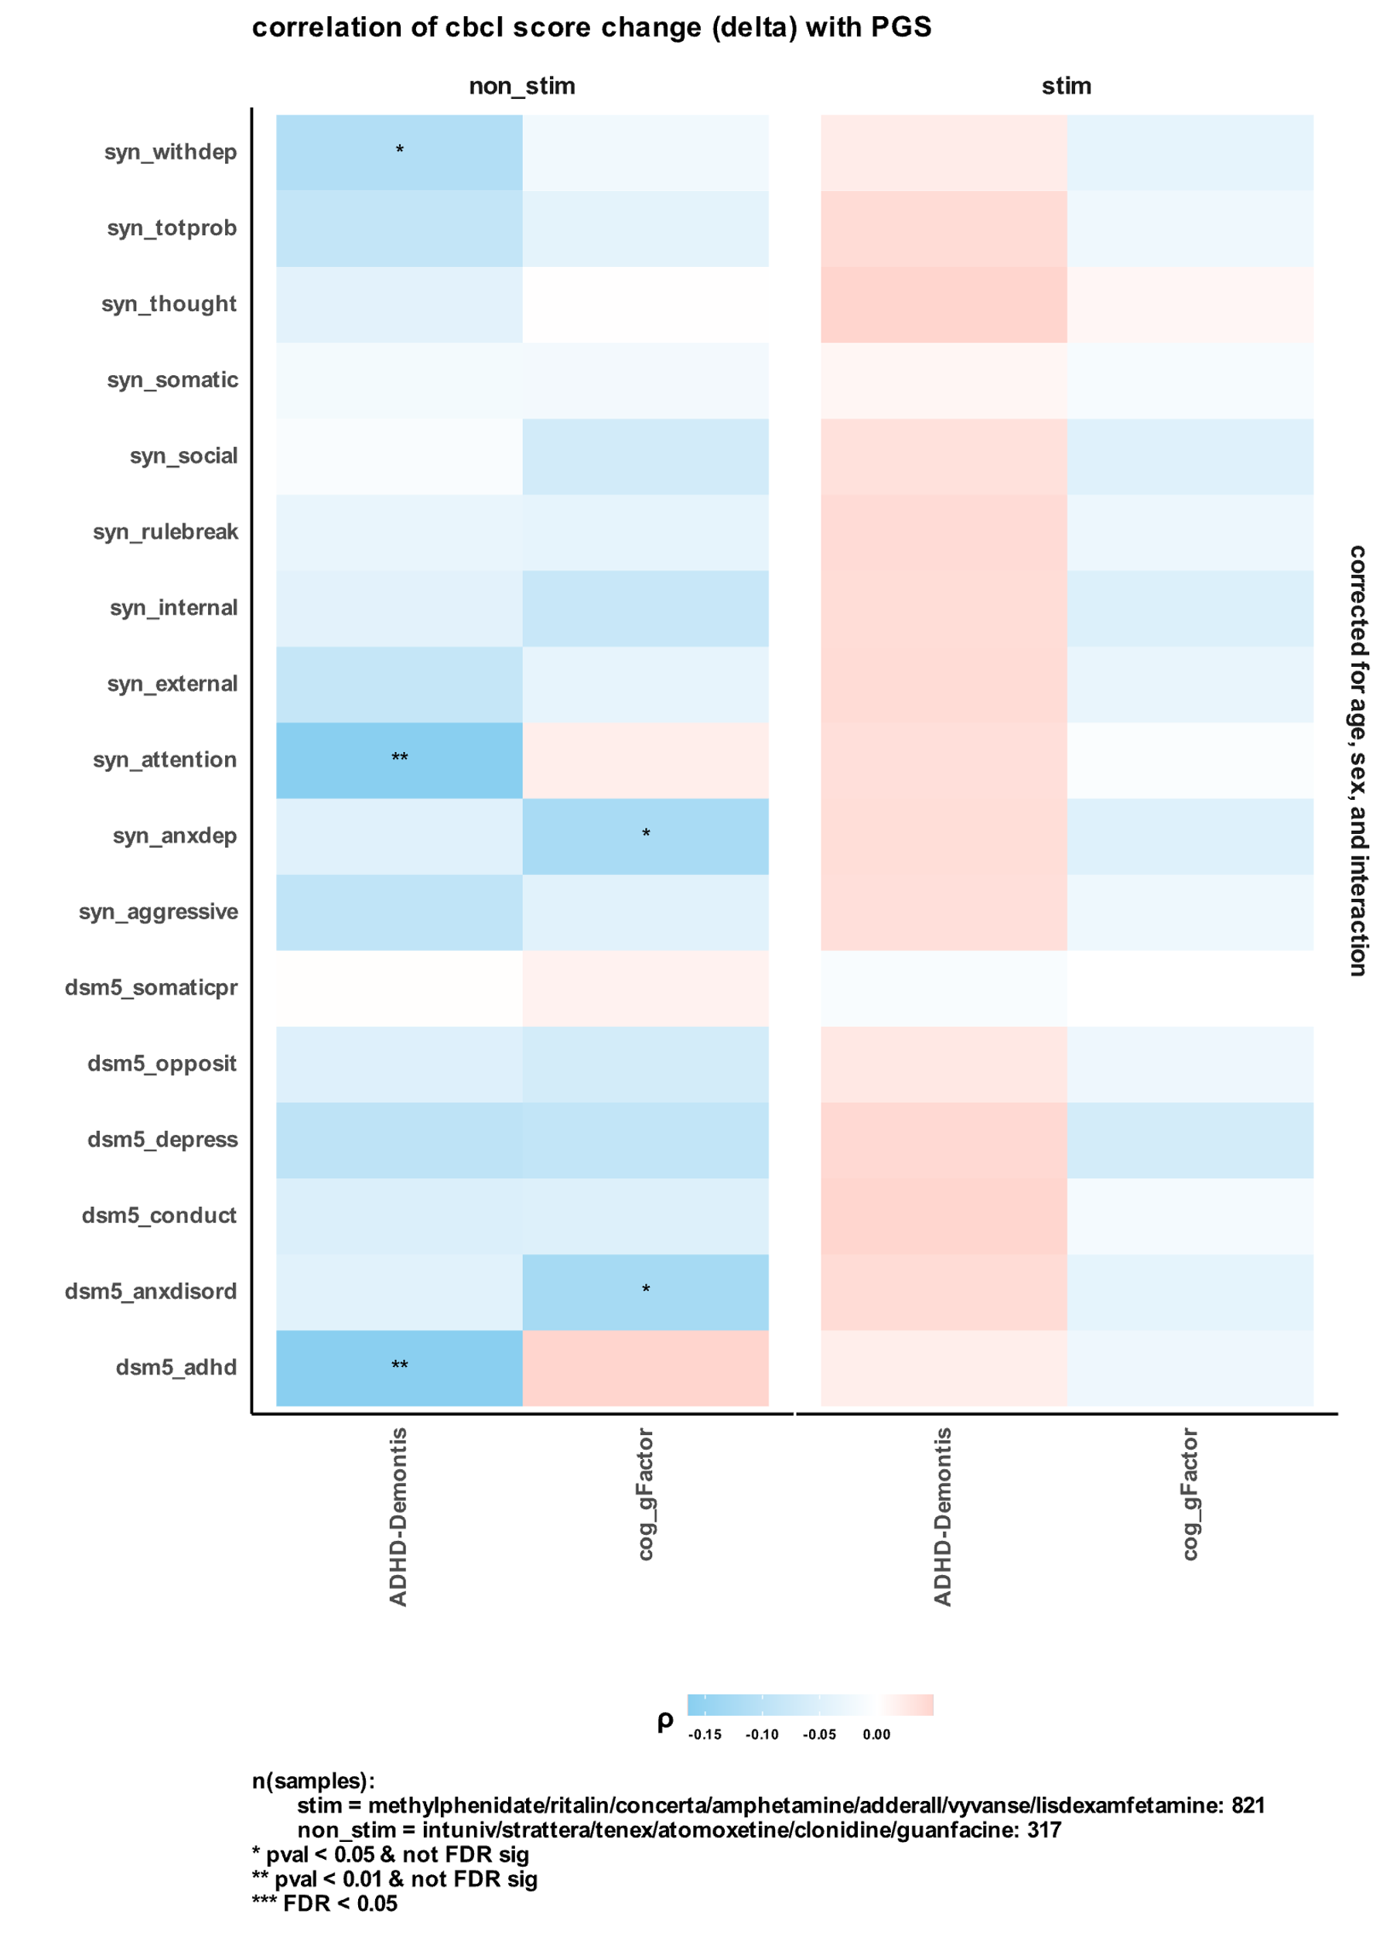

Subsequently, we sought to determine if the observed correlations extended to specific medications, focusing on the effects of methylphenidate (MPH) and guanfacine. For MPH, we found a consistent pattern that mirrored our observations for stimulants as a whole. Specifically, participants with higher cognitive gFactor PGS demonstrated fewer behavioral problems, including reduced DSM5 ADHD symptoms, conduct issues, syndromic attention, and social difficulties (Figure 3-A). Conversely, individuals with high ADHD PGS exhibited more social and DSM5 ADHD symptoms while taking methylphenidate. These findings indicate that MPH may have a differential impact on participants based on their genetic predisposition for cognitive abilities and ADHD.

Turning our attention to guanfacine, a non-stimulant medication, intriguing results emerged. We observed a negative correlation between CBCL deltas for DSM5 ADHD symptoms and syndromic attention subscale, and ADHD PGS (Figure 3-B). This suggests that guanfacine may be particularly beneficial for participants with higher genetic risk for ADHD, as evidenced by a significant reduction in attention and ADHD symptoms. These results imply that guanfacine's efficacy may be linked to the genetic background of individuals with ADHD, showing a potential for personalized treatment approaches.

Furthermore, we investigated inhibitory control in participants taking different medications, utilizing data from the stop signal task (SST) (Figure 3-C). Methylphenidate and lisdexamfetamine/Vyvanse, both stimulants for ADHD, demonstrated a positive correlation (nominal p-value < 0.05 for methylphenidate) with the number of 'no-response on go' trials. This suggests that these stimulants might lead to over-inhibition of action, with participants responding to stop signals but subsequently failing to execute the go response when the next 'GO' signal appeared. Interestingly, clonidine, another ADHD medication, showed an opposite pattern, with a negative correlation with the number of correct stops and number of “no-response on go” trials. Also, guanfacine showed a positive correlation between cognitive gFactor PGS and the delta of 'stop_doesnot_stop' trials. This suggests that participants with higher cognitive gFactor PGS and taking guanfacine were less able to inhibit their actions, whereas those with lower gFactor PGS exhibited better inhibitory control.

~~Unfortunately, we did not have enough samples to represent other stimulants and non-stimulants correlations, we could not generalize~~

These findings unveil a potential link between medication response and genetic predisposition for cognitive abilities and ADHD. The distinct patterns observed for methylphenidate and guanfacine provide valuable insights into the differential efficacy of stimulant and non-stimulant medications based on individual genetic profiles. Additionally, the SST data underscore the importance of considering genetic factors when assessing the impact of medications on inhibitory control in individuals with ADHD.

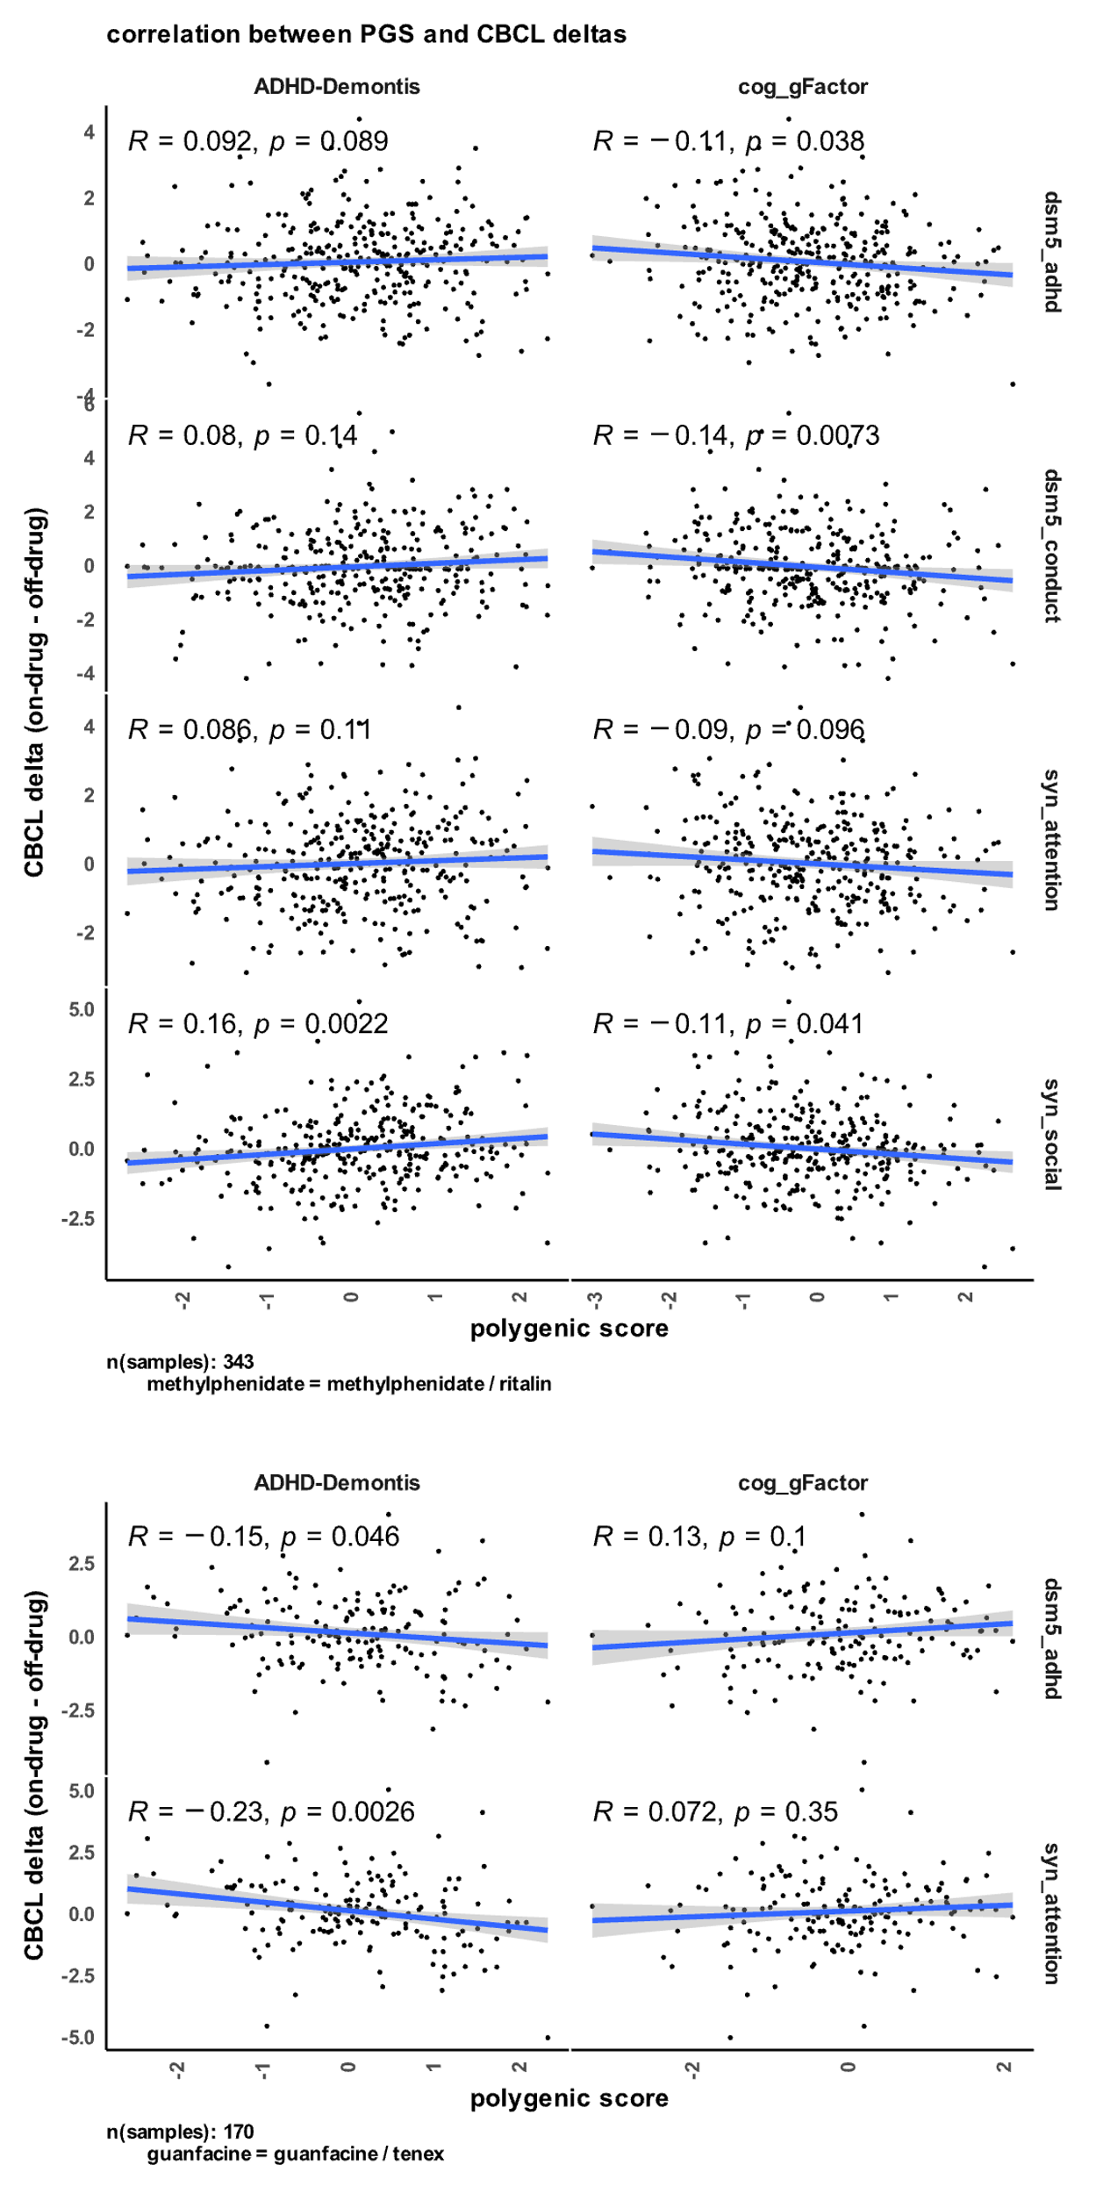

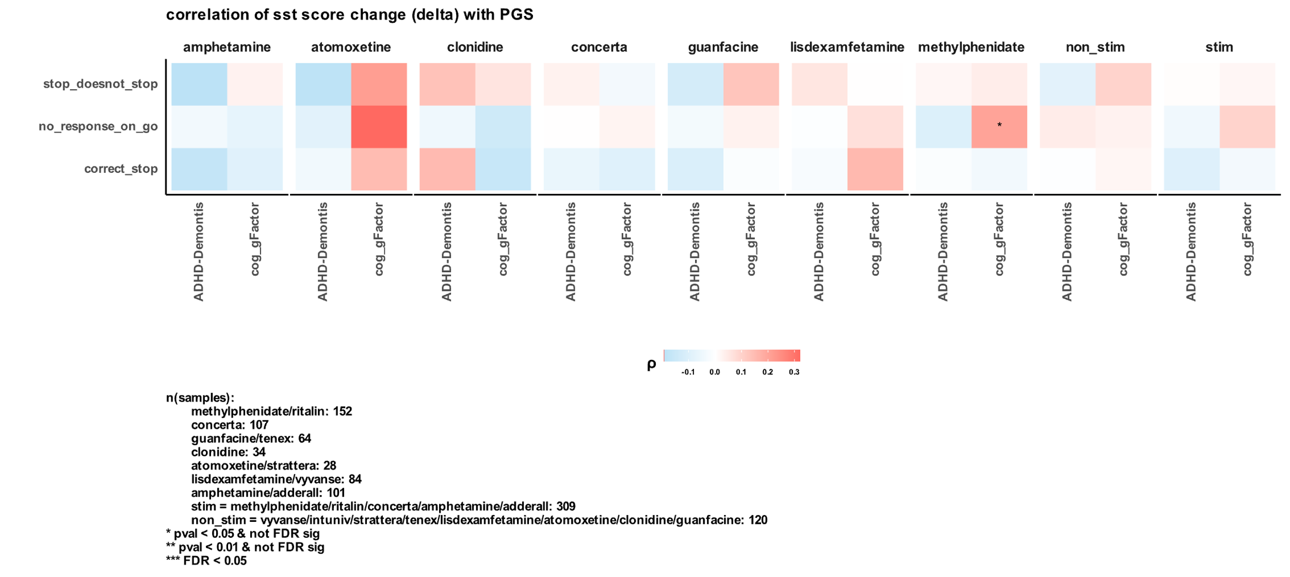

3.4. Validation of results in the SPARK cohort

To extend the generalizability of our finding that methylphenidate is benefiting participants with a higher cognitive gFactor PGS, we checked if the same correlation can be found using the SPARK cohort data.

## 3.4.1. Correlation between MPH Effectiveness and Communication Abilities

We examined the correlation between reported MPH effectiveness and the social communication abilities of the child as assessed by the Social Communication Questionnaire (SCQ). Our analysis revealed a significant correlation between the effectiveness of MPH and the child's communication abilities (Figure 3-A). Specifically, we found a positive correlation between reported MPH effectiveness and the child's use of verbal communication, including the ability to use phrases. Conversely, we observed a negative correlation between reported MPH effectiveness and behaviors such as odd communication patterns or deliberate self-injury.

## 3.4.2. Correlation between MPH Effectiveness and Cognitive Impairment

To explore the association between MPH effectiveness and cognitive abilities, we conducted a focused analysis on data from SPARK participants, specifically examining the relationship with cognitive impairment. Using a binary variable indicating the presence or absence of cognitive impairment, we investigated its correlation with reported MPH effectiveness. Our analysis revealed a significant negative correlation between MPH effectiveness and cognitive impairment (Odds Ratio = 0.7213; Fisher's Exact p-value = 0.0034) (Figure 3-B). This finding suggests that individuals with cognitive impairment may experience a lower effectiveness of MPH treatment compared to those without cognitive impairments. It highlights the importance of considering cognitive status when evaluating the therapeutic response to MPH in ADHD individuals, as it may be a critical factor influencing treatment outcomes. This finding also confirms what we observed in the ABCD cohort using PGS and CBCL.

## 3.4.3. Correlation between MPH effectiveness and PGS

To investigate the genetic underpinnings of the relationship between MPH effectiveness and cognitive abilities, we calculated polygenic scores (PGS) for all SPARK participants while accounting for the first five genetic principal components. We then explored the correlation between these PGS and reported MPH effectiveness. While the correlations we observed were not statistically significant, they exhibited the same directionality as the findings in the ABCD cohort. Specifically, we observed a positive direction of MPH effectiveness with cognitive gFactor PGS. This intriguing consistency between cohorts suggests that individuals with higher polygenic scores for gFactor may display a more favorable response to MPH treatment (Figure 1-C).

Furthermore, we extended our analysis to include amphetamines, which are another type of stimulant medication. Remarkably, we observed a similar direction of correlation between amphetamines' effectiveness and cognitive gFactor PGS. This intriguing finding reinforces the possibility of a genetic link between cognitive abilities and the responsiveness to stimulant medications, such as MPH and amphetamines.

These results provide promising evidence linking MPH effectiveness to both communication abilities and cognitive functioning.

While the correlations did not reach statistical significance, it is essential to interpret these results cautiously, as the sample sizes and genetic complexities might contribute to the lack of statistical power. Despite this limitation, the consistent trend across the SPARK and ABCD cohorts points to a potentially meaningful association between cognitive genetic factors and medication response.

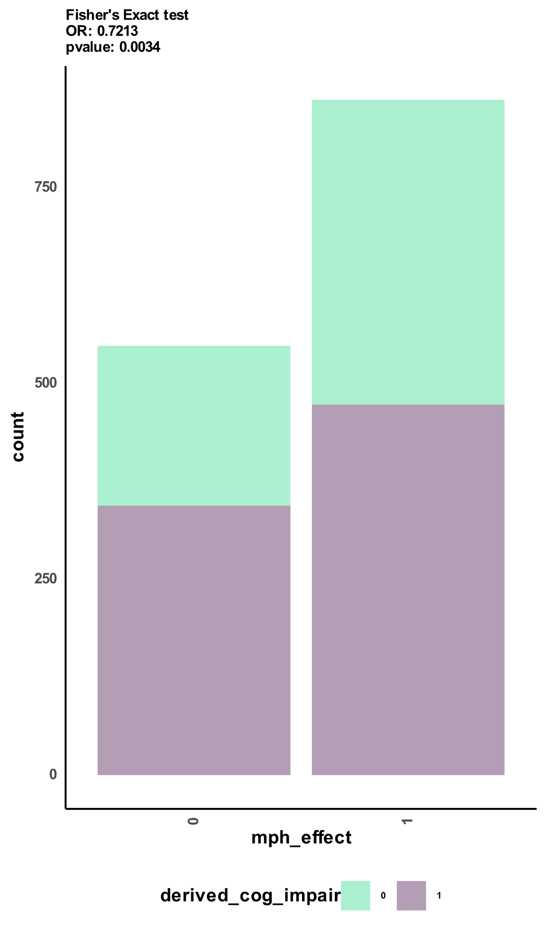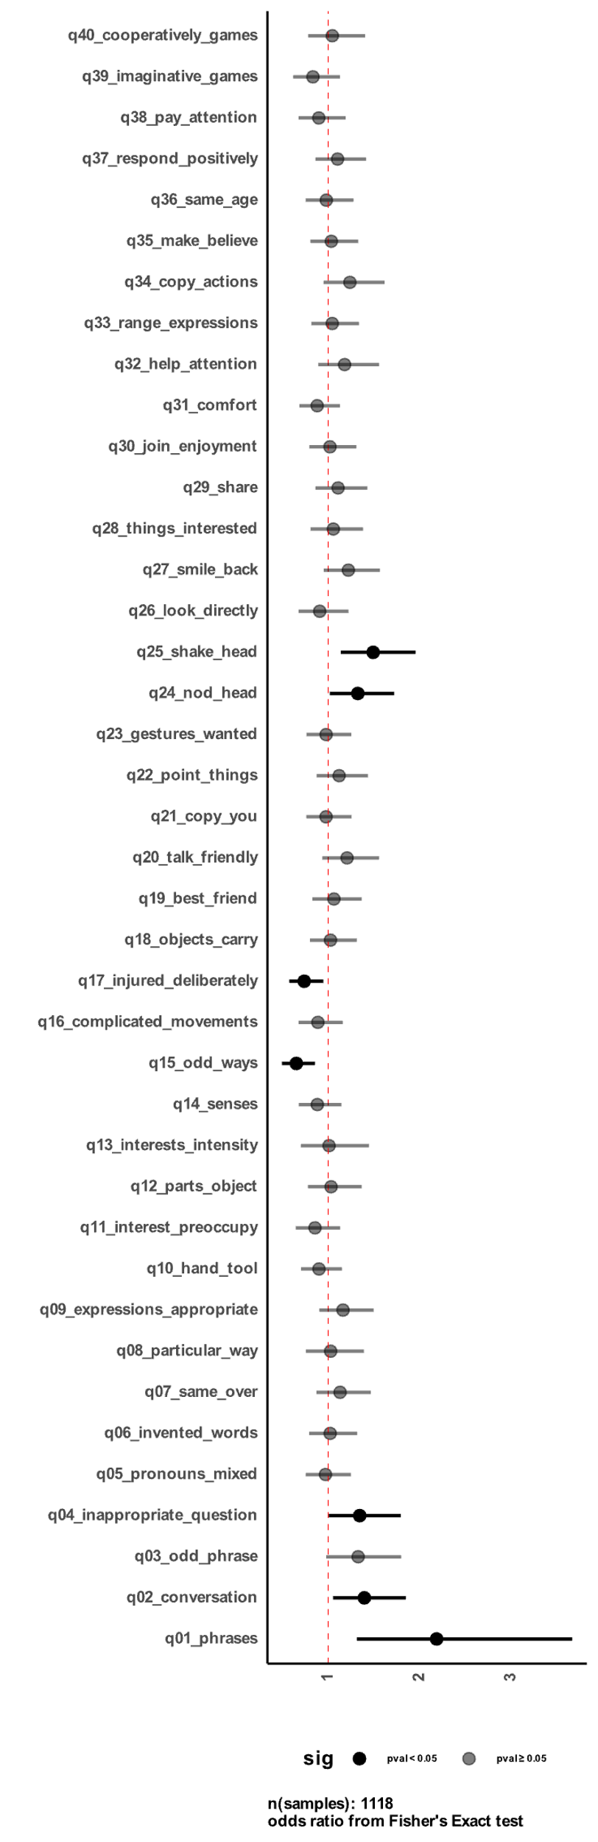

B

A

**Figure 1 Correlation between MPH effectiveness and communication abilities, cognitive impairment, and polygenic scores in the SPARK cohort.**  
A) shows odds ratio (OR) between reported methylphenidate effectiveness (MPH_effect) and different social communication questionnaire questions for 1118 samples from SPARK. B) correlation between cognitive impairment labels derived by SPARK and reported methylphenidate effectiveness by parents.

## 3.5. Predicting Drug Response using transcriptome imputation

To explore the feasibility of predicting drug response based on genetic signal, we developed a novel method that relies solely on the genetic profiles of individuals and the specific drug of interest. Utilizing eQTL weights, we imputed transcriptomic profiles specifically for excitatory neurons and compared them to the methylphenidate transcriptomic signature from the CMap database. The correlation between an individual's imputed transcriptome and the drug signature served as an indicator of drug effectiveness, with a negative correlation suggesting neutralization of the imputed transcriptome's effect, and a positive correlation indicating an exacerbation of gene expression in a similar direction to the imputed profile (See methods).

3.5.1. Correlation between predicted MPH response and PGS

Following the prediction of participants' response to methylphenidate using our innovative transcriptome imputation pipeline, we delved into understanding its association with the calculated cognitive gFactor polygenic scores (PGS). The predicted response, which quantifies the similarity between an individual's imputed transcriptome and the methylphenidate signature, is multiplied by -1 to facilitate interpretation (See methods).

Remarkably, our analysis revealed a significant (nominal p-value < 0.05) positive correlation between the predicted MPH response and cognitive gFactor PGS (Figure 4-B). This intriguing finding indicates that individuals with a higher genetic predisposition for enhanced cognitive functioning are more likely to exhibit a favorable response to methylphenidate treatment. Such an association suggests that cognitive abilities may play a crucial role in mediating the therapeutic efficacy of methylphenidate, underscoring the potential importance of genetic factors in shaping individual variability in drug response.

3.5.2. Behavior changes in the CBCL

Expanding our investigation into participants' behavioral changes, we explored the relationship between the predicted MPH response and alterations in their behavior problems, as assessed by the Child Behavior Checklist (CBCL). Our comprehensive analysis unveiled a substantial negative correlation (nominal p-value < 0.05) between the predicted response and the change (delta) in DSM5 ADHD symptoms (Figure 4-A). This indicates that individuals predicted to have a positive response to MPH, based on our transcriptome imputation-based tool, generally experienced a reduction in ADHD symptoms while undergoing the drug treatment.

These compelling results demonstrate the potential of transcriptome imputation-based prediction in identifying individuals who are more likely to respond positively to methylphenidate treatment. The significant correlation between the predicted response and improvements in ADHD symptomatology further supports the notion that genetic factors, particularly cognitive gFactor PGS, may play a pivotal role in mediating the therapeutic efficacy of methylphenidate.

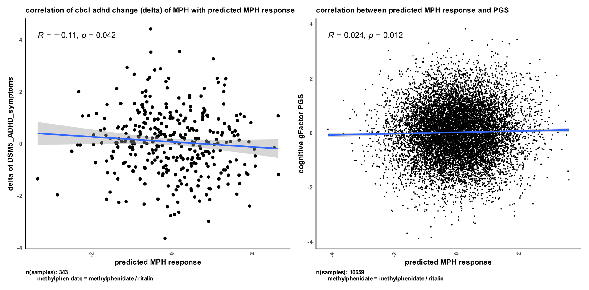

# 4. Discussion

In this study, we sought to explore the intricate interplay between genetic factors, medication response, and cognitive abilities in individuals with attention-deficit/hyperactivity disorder (ADHD). By leveraging data from two independent cohorts, SPARK and ABCD, we aimed to shed light on the potential influence of polygenic scores (PGS) for cognitive traits and ADHD on medication usage and response. Furthermore, we developed a novel approach based on transcriptome imputation to predict drug response solely using genetic profiles. Our findings provide valuable insights into the genetic underpinnings of medication response and have important implications for personalized medicine in ADHD treatment.

Our analysis of the SPARK and ABCD cohorts revealed intriguing associations between PGS for cognitive gFactor and ADHD with the usage of stimulant medications. Specifically, we observed a significant positive correlation between ADHD PGS and the usage of methylphenidate and amphetamines, which are commonly prescribed stimulant medications for ADHD treatment. This suggests that individuals with higher genetic predisposition for ADHD may be more likely to be prescribed these stimulant medications. On the other hand, we also found a significant negative correlation between cognitive PGS and the use of certain medications, including Adderall, Vyvanse, Clonidine, and Methylphenidate, in the ABCD cohort. These findings imply that individuals with higher genetic predisposition for cognitive abilities are less likely to be taking certain medications commonly prescribed for ADHD.

To investigate the impact of medication on participants' behavior, we examined the changes in behavior problems with and without taking ADHD medications. Our results demonstrated a notable trend for stimulant medications, where participants with higher ADHD PGS exhibited higher ADHD symptoms and other behavioral problems when taking stimulants. Conversely, participants with high cognitive gFactor PGS showed reductions in behavioral problems and ADHD symptoms when taking stimulants. This suggests that individuals with a higher genetic risk for ADHD may experience a less favorable response to stimulant medications, while those with higher cognitive abilities may benefit more from these medications. Notably, we observed similar patterns in the ABCD cohort, further supporting the robustness of these associations.

Interestingly, non-stimulant medications, such as guanfacine, showed a different pattern. We found a negative correlation between the CBCL deltas for DSM5 ADHD symptoms and syndromic attention subscale and ADHD PGS, indicating that individuals with higher ADHD PGS experienced a reduction in attention/ADHD symptoms when taking guanfacine. This suggests that guanfacine may be particularly beneficial for individuals with higher genetic predisposition for ADHD. These findings highlight the importance of considering genetic factors in determining medication response and suggest that individuals with different genetic profiles may benefit more from specific medication classes.

To explore the feasibility of predicting drug response based on genetic signal, we developed a novel method using transcriptome imputation. This innovative approach allowed us to predict drug response solely based on an individual's genetic profile and the specific drug under investigation. Our results demonstrated a significant positive correlation between the predicted response and cognitive gFactor PGS. This suggests that individuals with higher genetic predisposition for better cognitive functioning may exhibit a more favorable response to methylphenidate treatment. These promising findings highlight the potential of transcriptome imputation-based prediction in identifying individuals who are more likely to respond positively to methylphenidate treatment.

In conclusion, our study provides novel insights into the genetic basis of medication response in ADHD. We demonstrate the importance of considering genetic cognitive factors in determining drug effectiveness and propose a transcriptome imputation-based approach for predicting drug response. These findings have implications for personalized ADHD treatment strategies and highlight the potential of using genetic information to optimize medication selection for individuals with ADHD. Further research in larger and more diverse cohorts is warranted to validate and expand upon these findings, ultimately enhancing our understanding of medication response in ADHD and informing personalized treatment approaches.

# 5. Methods

## 5.1. Genotypes and polygenic scores for SPARK and ABCD

The genotyping and polygenic score methodologies employed in this study were previously documented in our group's publication (Taylor R Thomas, 2023).

### 5.1.1. Genotype quality control

Genotype quality control, imputation, and the computation of genetic principal components and polygenic scores were described in detail in (Taylor R. Thomas, 2022). The ABCD genotypes underwent quality control measures to address missingness and contamination before their official release. Hence, no additional quality control steps were conducted prior to genotype imputation. As for SPARK, we utilized the genotypes from the integrated whole-exome sequencing (iWES1) 2022 Release, along with the SPARK whole-genome sequencing (WGS) Releases 2, 3, and 4. The SPARK iWES1 dataset (N = 69,592) had already undergone quality control, including the removal of samples exhibiting heterozygosity or high missingness. Thus, no further quality control was performed by our team before genotype imputation. Moreover, the SPARK iWES1 dataset provided genetic ancestry assignments based on the 1000 Genomes populations (Genomes Project et al., 2015).

In contrast, SPARK WGS Releases 2 (N = 2,365), 3 (N = 2,871), and 4 (N = 3,684) were not subjected to quality control upon release. Consequently, we conducted quality control using PLINK (Purcell et al., 2007) before proceeding with genotype imputation. Our quality control process involved the exclusion of participants already present in the iWES1 dataset. Additionally, we eliminated variants and participants exhibiting missingness greater than 0.1 and 0.2, respectively. Subsequently, we merged the three WGS releases and excluded any participant whose heterozygosity (F statistic) deviated more than 3 standard deviations from the mean heterozygosity across the three releases. We employed the TopMed reference panel (Taliun et al., 2021) to identify strand flips. Ultimately, the final sample size for WGS 2-4 comprised N = 8,152 individuals.

### 5.1.2. Genotype imputation and merging

We employed the Michigan Imputation Server (Das et al., 2016)to impute the genotypes of ABCD, SPARK iWES1, and quality-controlled SPARK WGS 2-4 datasets to the TopMed reference panel (Taliun et al., 2021). Imputation was carried out using phasing and quality control steps, yielding variants with an imputation quality r2 > 0.3. Following imputation, the variants were filtered to retain only the HapMap SNPs (N = 1,054,330 variants) with an imputation quality r2 > 0.8, utilizing bcftools (Danecek et al., 2021). The variants were then converted from the hg38 to hg19 reference genome using the VCF-liftover tool (<https://github.com/hmgu-itg/VCF-liftover>), and their alleles were normalized accordingly. Finally, the files were merged, and only variants with 0% missingness were retained, resulting in a final dataset size of N = 914,328 variants.

### 5.1.3. Genetic ancestry and principal components

To compute the genetic principal components (PCs), we utilized the bigsnpr package (Prive et al., 2018) following the recommended guidelines outlined by the authors (Prive et al., 2020). For a detailed tutorial, we followed the steps provided in their documentation: [link: <https://privefl.github.io/bigsnpr/articles/bedpca.html>]. In summary, the following steps were performed:

1. We employed the snp_plinkKINGQC function to identify and exclude related participants using the KING threshold of 2-3.5

2. Principal component analysis (PCA) was conducted using the bed_autoSVD function solely on unrelated participants.

3. Outliers among the principal components were detected and subsequently removed.

4. The principal components were recalculated.

5. The bed_projectSelfPCA function was used to project the principal components onto the entire cohort.

To assign genetic ancestry, we performed k-means clustering utilizing the top 40 principal components, with K set to 5 to correspond to the five populations identified in the 1000 Genomes project (Genomes Project et al., 2015). The genetic ancestry labels from the iWES1 dataset were employed to assign labels to the five genetic population clusters.

### 5.1.4. Polygenic score calculations

Polygenic scores (PGS) were calculated using LDpred2 (Prive et al., 2021) and the bigsnpr tools (Prive et al., 2018) in R (R-Core-Team). As SPARK is a family-based dataset, we utilized an external LD reference based on 362,320 individuals from the UK Biobank, provided by the authors of LDpred2. This reference was used to calculate the genetic correlation matrix, estimate heritability, and calculate infinitesimal beta weights.

The PGS were derived from the following individual genome-wide association studies (GWAS) ADHD (Demontis et al., 2019). Additionally, the PGS for the eight cognitive traits (fluid intelligence (verbal_numerical reasoning), matrix pattern completion (matrix), tower rearranging (tower_rearranging), numeric memory (mem), reaction time (reaction_time), symbol digit substitution (symbol_digit), trail making (trail_making), and a G factor score (gFactor)) were obtained from the same study (de la Fuente et al., 2021).

To account for potential confounding effects, we conducted linear regression residualization by incorporating the first five genetic principal components. Subsequently, the PGS were Z-scaled to have a mean of 0 and a standard deviation (σ) of 1.

## 5.2. SPARK methylphenidate effectiveness correlations

### 5.2.1. SPARK participants

## For our analysis of methylphenidate (MPH) effectiveness, we utilized a survey that was administered to a subset of SPARK participants. The survey, completed by parents, focused on aspects such as sleep patterns, eating habits, and gastrointestinal issues in their children. Among the questions, one specifically targeted the medical history of the child and assessed the effectiveness of methylphenidate as a binary variable: 0 for not effective and 1 for effective. The classification was solely based on the perceived effectiveness of the drug without considering any potential adverse effects. Participants were asked about the drug's effectiveness, irrespective of whether they were currently taking it or had taken it in the past.

We utilized the data collected from this question as the predicted response for drug effectiveness and compared it to other surveys conducted by SPARK for the same participants. The sample included 1460 participants, with a mean age of 160.580 months (SD = 65.164).

### 5.2.2. social communication questionnaire

In addition to the effectiveness survey, parents also reported data from the Social Communication Questionnaire (SCQ) for the same participants. The SCQ is a reliable screening tool used to assess social communication abilities and identify potential indicators of autism spectrum disorder (ASD). Comprising 40 structured questions, the SCQ evaluates various aspects of social interaction, communication skills, and behavioral patterns commonly associated with ASD. It covers areas such as eye contact, gestures, facial expressions, reciprocal conversation, interests, and repetitive behaviors. The SCQ offers a comprehensive evaluation of social communication abilities, making it valuable for research investigations and clinical assessments of ASD. Each question in the SCQ is answered with a yes or no response.

To examine the relationship between MPH effectiveness and individual SCQ questions, we conducted Fisher's Exact tests using the 'fisher.test()' function in R for each question independently. We extracted the odds ratio and nominal p-value from these tests. The table below summarizes the sample included in the analysis and reports the questions with significant odds ratios associated with MPH effectiveness.

**Table 1 social communication questionnaire associations with MPH effectiveness**

|  |  |  |  |  |
| --- | --- | --- | --- | --- |
| Question | No | Yes | Odds Ratio | p-value |
| MPH effect | 482 | 758 | - | - |
| q01_phrases | 82 | 1155 | 2.0753643 | 0.0019874569 |
| q15_odd_ways | 380 | 855 | 0.66784639 | 0.0019272163 |
| q17_injured_deliberately | 549 | 685 | 0.77794502 | 0.0344979721 |
| q24_nod_head | 402 | 833 | 1.31400727 | 0.0292520573 |
| q25_shake_head | 350 | 882 | 1.48568113 | 0.0023010170 |

|  |  |  |  |  |  |
| --- | --- | --- | --- | --- | --- |
| **Sex** | Age avg | Age sd | Age min | Age max | Samples count |
| Female | 146.65968586387400 | 40.709554004793800 | 36 | 234 | 191 |
| Male | 140.00224215246600 | 40.03259047628670 | 55 | 233 | 892 |

### 5.2.3. cognitive impairment

To explore the association between MPH effectiveness and cognitive impairment among the participants, we conducted a Fisher's Exact test. The cognitive impairment variable was derived as a binary vector from the SPARK cohort: 0 denoting no cognitive impairment and 1 indicating cognitive impairment. This variable served as a predictor for multiple measurements in the participants. The table below presents a summary of the sample included in this section.

**Table 2 cognitive impairment counts for participants with reported MPH effectiveness**

|  |  |  |
| --- | --- | --- |
| Question | No | Yes |
| MPH effect | 548 | 862 |
| derived_cog_impair | 593 | 817 |

### 5.2.4. polygenic scores

After adjusting the polygenic scores (PGS) for all ABCD and SPARK participants using the first five genetic principal components, we specifically included participants who had reported MPH effectiveness in the SPARK dataset. Subsequently, we examined the correlation between PGS and MPH effectiveness using the 'cor()' function in R. The reported values in Figure 1-C represent the Spearman's rank-based correlation coefficients along with their nominal p-values.

## 5.3. ABCD cohort

The present study utilized data from the Adolescent Brain Cognitive Development (ABCD) dataset, release 5.0, a comprehensive and longitudinal study conducted in the United States. The primary objective of the ABCD dataset is to examine brain development in relation to behavioral, cognitive, and social outcomes among adolescents. The dataset comprises a diverse sample of over 11,000 children, initially aged 9 to 10 years at baseline, who are followed through adolescence with multiple assessments conducted over several years. These assessments cover a wide range of domains, including neuroimaging, neurocognitive testing, psychosocial questionnaires, and physical health measures. By incorporating these various assessments, the ABCD study provides a multidimensional dataset that facilitates investigations into different aspects of brain development and associated outcomes during the crucial period of adolescence.

### 5.3.1. Stop signal fMRI task.

In the ABCD dataset, the Stop Signal fMRI Task (SST) was utilized to assess inhibitory control and impulsivity in adolescents. This task measures the ability to inhibit prepotent responses by presenting participants with a series of go trials where they need to respond quickly to a specific stimulus. On certain trials, a stop signal is presented after the go signal, indicating that participants should inhibit their response. By manipulating the timing of the stop signal, researchers can estimate the stop signal reaction time (SSRT), which reflects the individual's ability to successfully inhibit their responses. The SST provides valuable insights into the neural mechanisms underlying inhibitory control and impulsivity, contributing to the understanding of cognitive processes related to behavioral regulation in the ABCD study.

During the SST, typically two trial runs are conducted to familiarize participants with the task and obtain reliable measurements of inhibitory control. The first trial run serves as an introduction to the task instructions and structure, allowing participants to become comfortable and understand the requirements for response inhibition. For this analysis, we focused on the data from the first run since most participants did not complete the second run.

We extracted specific variables of interest from the evaluated SST data as measures of attention/action-inhibition. These variables include the number of correct stop answers within the specified time, the number of no responses on go trials, and the number of stop signal doesn't stop trials.

These variables were found to have a significant correlation with the interview age of the participants, and their sex. To account for that, we conducted a regression analysis using the glm() function in R, fitting the formula glm(y ~ interview_age + sex + interview_age:sex, family = poisson()) and obtaining the residuals.

For each one of the questions, we calculated the change (delta) in participant’s performance based on the status of taking MPH or not. The delta was defined as: (participant’s score on MPH) - (participant’s score off MPH)

For participants that had multiple measures per MPH status, their score was averaged.

|  |  |  |  |  |  |  |
| --- | --- | --- | --- | --- | --- | --- |
| **Sex** | Drug | Age avg | Age sd | Age min | Age max | Samples count |
| Female | amphetamine | 137.13392857142900 | 19.437817480140300 | 108 | 185 | 48 |
| Female | atomoxetine | 136.19354838709700 | 20.645288978099800 | 108 | 178 | 13 |
| Female | clonidine | 139.0408163265310 | 20.483691870682400 | 107 | 182 | 20 |
| Female | concerta | 138.86458333333300 | 20.18525766971980 | 107 | 185 | 40 |
| Female | guanfacine | 137.17857142857100 | 19.2515474163008 | 108 | 185 | 25 |
| Female | lisdexamfetamine | 135.15277777777800 | 19.49695514127550 | 108 | 185 | 31 |
| Female | methylphenidate | 136.3227848101270 | 18.894028641612800 | 107 | 186 | 70 |
| Male | amphetamine | 138.27906976744200 | 19.893286020747900 | 108 | 186 | 106 |
| Male | atomoxetine | 137.81690140845100 | 21.020608839323700 | 108 | 186 | 29 |
| Male | clonidine | 138.65853658536600 | 19.15577436855890 | 108 | 186 | 35 |
| Male | concerta | 140.0557768924300 | 20.020711188517400 | 107 | 186 | 103 |
| Male | guanfacine | 139.28494623655900 | 20.086017437102400 | 108 | 183 | 77 |
| Male | lisdexamfetamine | 140.4267782426780 | 21.24907003592850 | 107 | 188 | 95 |
| Male | methylphenidate | 138.05026455026500 | 19.287717190289400 | 107 | 186 | 161 |

### 5.3.2. Child Behavior Checklist (CBCL)

In addition to the Stop Signal fMRI Task (SST), the ABCD dataset includes parent-reported data on their child's behavior using the Child Behavior Checklist (CBCL). The CBCL is a widely used questionnaire that assesses various behavioral and emotional problems in children and adolescents. Parents provide ratings on a range of behavioral items, allowing for the assessment of different behavioral domains.

To investigate the effects of methylphenidate on behavior, we calculated the change (delta) in CBCL subscale scores based on the status of taking MPH or not. Similar to the SST analysis, the delta was defined as: (participant's CBCL subscale score on MPH) - (participant's CBCL subscale score off MPH)

As some participants had multiple measures per MPH status, their scores were averaged. To account for age and sex, which are known to influence behavioral outcomes, we conducted a regression analysis using the glm() function in R. The formula glm(y ~ interview_age + sex + interview_age:sex, family = poisson()) was used to obtain the residuals. These residuals represent the change in CBCL subscale scores, adjusted for age and sex, which allowed us to examine the effect of taking MPH on behavioral outcomes independently of age and sex influences.

|  |  |  |  |  |  |  |
| --- | --- | --- | --- | --- | --- | --- |
| **Sex** | Drug | Age avg | Age sd | Age min | Age max | Samples count |
| Female | amphetamine | 139.28938906752400 | 18.304234921929100 | 108 | 185 | 77 |
| Female | atomoxetine | 139.16666666666700 | 18.15915802234020 | 108 | 179 | 20 |
| Female | clonidine | 138.26168224299100 | 18.10313037070750 | 107 | 182 | 27 |
| Female | concerta | 141.5191637630660 | 18.238670647571100 | 107 | 185 | 66 |
| Female | guanfacine | 139.06201550387600 | 17.638625911079600 | 108 | 185 | 33 |
| Female | lisdexamfetamine | 136.1898148148150 | 17.401312112061 | 108 | 185 | 54 |
| Female | methylphenidate | 140.38307349665900 | 18.09499433536300 | 107 | 186 | 109 |
| Male | amphetamine | 139.775204359673 | 18.060603930962200 | 107 | 186 | 181 |
| Male | atomoxetine | 140.57731958762900 | 19.02130523601870 | 108 | 186 | 46 |
| Male | clonidine | 139.875 | 17.13121747475350 | 108 | 186 | 69 |
| Male | concerta | 141.61668839634900 | 18.282284166518600 | 107 | 186 | 180 |
| Male | guanfacine | 140.506993006993 | 18.019884523148900 | 107 | 183 | 142 |
| Male | lisdexamfetamine | 141.64948453608200 | 18.72725217206960 | 107 | 188 | 137 |
| Male | methylphenidate | 140.65599268069500 | 18.120542984852300 | 107 | 186 | 266 |

### 5.3.3. Polygenic scores

After adjusting the polygenic scores (PGS) for all participants in the SPARK and ABCD cohorts using the first five genetic principal components, we focused on participants from the ABCD dataset who had reported performance data in the first run of the SST. We then examined the correlation between the PGS and the calculated deltas for both: the SST, and the CBCL. The correlation was performed in R, using the ‘cor()’ function with specifying the method to be Spearman rank-based correlation.

## 5.4. Transcriptome imputation

To investigate how different genetic variants influence gene expression in specific cell types, we utilized cis-eQTL weights obtained from (Bryois et al., 2022). These weights were assigned to each variant-gene pair and were derived using a specific statistical model that accounted for various factors such as genotype, cell type, principal components, study, disease status, and individual-specific random effects. The eQTLs were derived by the following model as defined by the authors:

$raw counts (each gene)\sim genotype (0,1,2)+ cell_type+ genotype:cell_type_eqtl (cell type in which the eQTL was discovered, coded as 0,1)+ PC 1-3 genotype matrix + PC 1-5 expression matrix + study + disease_status+ (1│individual)(random effect)$

The study provided cis-eQTL weights for eight different cell types, including astrocytes, endothelial cells, excitatory neurons, inhibitory neurons, microglia, oligodendrocytes, OPCs (oligodendrocyte progenitor cells), and pericytes. However, for our investigation into methylphenidate response, we focused solely on excitatory neurons. To narrow down the list of eQTLs, we filtered them based on a false discovery rate (FDR) threshold of less than 0.05, resulting in a final set of 328,061 unique significant eQTLs out of the original 2,438,542 eQTLs.

To impute gene expression in excitatory neurons for individuals, we performed a simple matrix multiplication using the following formula:

$Imputed_tx= Genotypes_Matrix x cell_type_Weights_Matrix$

The cell_type_Weights_Matrix represents the weights matrix derived from (Bryois et al., 2022). It has dimensions MxN, where M represents the number of variants and N represents the number of genes. The Genotypes_Matrix, on the other hand, has rows representing individuals and columns representing genotypes. The values in this matrix indicate the type of genotype alleles found for each individual (0 for homozygous reference, 1 for heterozygous, and 2 for homozygous alternate).

For our analysis, we used the Genotypes_Matrix specific to participants from the Adolescent Brain Cognitive Development (ABCD) study. The ABCD study is one of the largest long-term studies funded by the National Institutes of Health (NIH) that focuses on brain development and child health in the United States. It includes approximately 11,000 children aged 9-10 years at the beginning of the study.

After imputing transcriptome data for the ABCD participants, we further standardized the imputed values on a gene level by z-scaling them, ensuring a mean of 0 and a standard deviation (σ) of 1. This normalization step allows for easier interpretation and comparison of gene expression levels across individuals.

## 5.5. Drug response

### 5.5.1. calculating polygenic drug response

To assess individuals' response to methylphenidate (MPH), we calculated the correlation between their imputed transcriptome in excitatory neurons and the drug signature obtained from the connectivity map (CMap)[3] database developed by the BROAD Institute. The CMap database provides a measure of cellular response to different perturbagens (including drugs) in various cell lines.

The drug signature matrix for each drug is a 1xG matrix, where G represents the total number of genes with measured gene expression after introducing the drug to the cell line. The gene expression values in the signature matrix range from 0 to 1, representing fluorescence intensity. For our analysis, we used the fitted data from the CMap, which controls for the cell line and drug dose, ensuring that the signature reflects the drug effect specifically.

To calculate the correlation, we employed the cor() function in R, specifically using Spearman rank-based correlation. This correlation measures how different an individual's imputed gene expression is compared to the drug signature. Before calculating the correlation, we accounted for genes that had a measured change in the drug signature but did not have imputed transcriptome values (either due to a lack of eQTLs found in the sample or the gene not having significant eQTLs with weights). In these cases, we added those genes to the imputed transcriptome vector with a value of 0.

The calculated correlations serve as a measure of how an individual's imputed gene expression differs from the drug signature. Based on these correlations, individuals were categorized as positive responders to the drug if their imputed tissue expression had a negative correlation with the drug perturbation signature. Conversely, individuals were categorized as negative responders if they had a positive correlation. In this context, a negative correlation indicates that the drug is expected to reverse the imputed transcriptome, thereby normalizing the gene expression.

To ensure consistency in the interpretation, we multiplied the calculated correlations by -1 to reverse the sign. Thus, a positive value in the correlation indicates that an individual is predicted to be a responder to methylphenidate (MPH).

5.5.2. comparing predicted polygenic MPH response to participants’ CBCL deltas and cognitive gFactor PGS

To assess the relationship between the predicted polygenic response to methylphenidate (MPH) and participants' CBCL deltas, we conducted Spearman’s rank-based correlation analyses using the cor() function in R. We also conducted a Pearson’s correlation between the predicted MPH response and participants cognitive gFactor PGS as shown in Figure 4-B.

# 6. Limitations

Several limitations should be considered when interpreting the findings of this study. Firstly, the use of subjective reporting for MPH effectiveness and social communication abilities relies on the accuracy of parent reports, which can be influenced by various factors such as recall bias or subjective perceptions. Objective measures, although employed in the validation stage, still have inherent limitations, and may not fully capture the complexity of drug response in real-world settings. The objective measure, mainly SST, was not designed to specifically study drug effectiveness. However, we used it to study the variability in performance based on the drug history for participants.

Another limitation is the reliance on transcriptomic imputation for predicting drug response. While this approach provides valuable insights into gene expression patterns, it relies on the assumption that imputed values accurately represent the true transcriptomic profile of the individual. It is also worth noting that the eQTL weights were derived from postmortem samples. The imputation process itself introduces inherent uncertainty and potential biases, which may affect the accuracy of the predicted drug response.

Furthermore, the study's sample size, although representative of the targeted populations, may limit the generalizability of the findings. The SPARK and ABCD cohorts, while providing valuable data, may not fully capture the diversity and heterogeneity present in the broader population of individuals with neurodevelopmental disorders.

Additionally, the regression models used in this study are based on associations and correlations and do not establish causality. Other factors beyond the genetic and transcriptomic profiles, such as environmental influences or individual-specific physiological processes, could contribute to the observed drug response variations.

Lastly, it is worth noting that the study focused specifically on methylphenidate response in individuals with neurodevelopmental disorders. The generalizability of the findings to other medications or different patient populations requires further investigation.

These limitations highlight the need for caution when interpreting the results and suggest avenues for future research. Larger and more diverse cohorts, rigorous validation of predictive models, and longitudinal studies assessing the long-term effects of predicted drug response are essential to further refine and validate the proposed method for personalized pharmacological management in neurodevelopmental disorders.

# 7. Acknowledgements

Data used in the preparation of this article were obtained from the Adolescent Brain Cognitive DevelopmentSM (ABCD) Study (https://abcdstudy.org), held in the NIMH Data Archive (NDA). This is a multisite, longitudinal study designed to recruit more than 10,000 children age 9-10 and follow them over 10 years into early adulthood. The ABCD Study® is supported by the National Institutes of Health and additional federal partners under award numbers U01DA041048, U01DA050989, U01DA051016, U01DA041022, U01DA051018, U01DA051037, U01DA050987, U01DA041174, U01DA041106, U01DA041117, U01DA041028, U01DA041134, U01DA050988, U01DA051039, U01DA041156, U01DA041025, U01DA041120, U01DA051038, U01DA041148, U01DA041093, U01DA041089, U24DA041123, U24DA041147. A full list of supporters is available at <https://abcdstudy.org/federal-partners.html>. A listing of participating sites and a complete listing of the study investigators can be found at<https://abcdstudy.org/consortium_members/>. ABCD consortium investigators designed and implemented the study and/or provided data but did not necessarily participate in the analysis or writing of this report. This manuscript reflects the views of the authors and may not reflect the opinions or views of the NIH or ABCD consortium investigators.

The ABCD data repository grows and changes over time. The ABCD data used in this report came from [NIMH Data Archive Digital Object Identifier [10.15154/8873-zj65](http://dx.doi.org/10.15154/8873-zj65)]. DOIs can be found at https://nda.nih.gov/abcd.

The SPARK data can be obtained at SFARI Base: <https://base.sfari.org>.

# 8. Data availability

The data used in this study is subject to data access and sharing policies set forth by the respective cohorts and databases. The SPARK (Simons Foundation Powering Autism Research for Knowledge) cohort data can be accessed through an application process via the SPARK website (https://sparkforautism.org/). Researchers interested in accessing the ABCD (Adolescent Brain Cognitive Development) cohort data can submit data access requests to the ABCD Study Data Repository (https://nda.nih.gov/abcd).

The imputation weights used in this study are derived from publicly available resources. The specific sources and versions of the genetic data are detailed in the Methods section. Researchers can access these resources directly to obtain the necessary genetic information.

The connectivity map (CMap) drug perturbation signature data used to compute drug response correlations can be obtained from the BROAD Institute's CMap website (https://clue.io/).

Due to the sensitive nature of the participant data, including clinical and behavioral information, access to individual-level data from the SPARK and ABCD cohorts may require adherence to ethical and privacy considerations. Researchers interested in accessing the individual-level data should consult the respective cohort data access policies and procedures, ensuring compliance with relevant legal and ethical guidelines.

In summary, access to the data used in this study is subject to the policies and procedures of the SPARK and ABCD cohorts, as well as the availability of publicly accessible resources. Researchers can refer to the cohort websites and associated repositories for detailed information on data access and availability.

**9. Code availability**

To promote transparency and reproducibility, the code used for data analysis, statistical modeling, and generation of results and figures can be found here [link].

# 10. Funding

[ask Jake]

# 11. Conflicts of interest

The authors declare that the research was conducted in the absence of any commercial or financial relationships that could be construed as a potential conflict of interest.

# 12. Author contributions

ME contributed to the study design, generating the imputed transcriptome, predicting drug response, processing the data, performing the statistical analyses, and writing the manuscript. TRT contributed to processing the data, genotype imputations, generating the polygenic scores, and writing the manuscript. LCG contributed to processing the data. JJM contributed to study design and writing the manuscript.

# 13. References

Advokat, C., & Scheithauer, M. (2013). Attention-deficit hyperactivity disorder (ADHD) stimulant medications as cognitive enhancers. *Front Neurosci*, *7*, 82. <https://doi.org/10.3389/fnins.2013.00082>

American-Academy-of-Pediatrics. (2022). Common ADHD Medications & Treatments for Children. Retrieved 06/19/2023, from <https://www.healthychildren.org/English/health-issues/conditions/adhd/Pages/Determining-ADHD-Medication-Treatments.aspx>

Belle, D. J., & Singh, H. (2008). Genetic factors in drug metabolism. *Am Fam Physician*, *77*(11), 1553-1560. <https://www.ncbi.nlm.nih.gov/pubmed/18581835>

Bryois, J., Calini, D., Macnair, W., Foo, L., Urich, E., Ortmann, W., Iglesias, V. A., Selvaraj, S., Nutma, E., Marzin, M., Amor, S., Williams, A., Castelo-Branco, G., Menon, V., De Jager, P., & Malhotra, D. (2022). Cell-type-specific cis-eQTLs in eight human brain cell types identify novel risk genes for psychiatric and neurological disorders. *Nat Neurosci*, *25*(8), 1104-1112. <https://doi.org/10.1038/s41593-022-01128-z>

CDC, C. f. D. C. a. P. (2022, August 9, 2022). *Data and Statistics About ADHD*. CDC. Retrieved June 16th from <https://www.cdc.gov/ncbddd/adhd/data.html>

Chang, J. C., Lin, H. Y., Lv, J., Tseng, W. I., & Gau, S. S. (2021). Regional brain volume predicts response to methylphenidate treatment in individuals with ADHD. *BMC Psychiatry*, *21*(1), 26. <https://doi.org/10.1186/s12888-021-03040-5>

Cortese, S., Adamo, N., Del Giovane, C., Mohr-Jensen, C., Hayes, A. J., Carucci, S., Atkinson, L. Z., Tessari, L., Banaschewski, T., Coghill, D., Hollis, C., Simonoff, E., Zuddas, A., Barbui, C., Purgato, M., Steinhausen, H. C., Shokraneh, F., Xia, J., & Cipriani, A. (2018). Comparative efficacy and tolerability of medications for attention-deficit hyperactivity disorder in children, adolescents, and adults: a systematic review and network meta-analysis. *Lancet Psychiatry*, *5*(9), 727-738. <https://doi.org/10.1016/S2215-0366(18)30269-4>

Danecek, P., Bonfield, J. K., Liddle, J., Marshall, J., Ohan, V., Pollard, M. O., Whitwham, A., Keane, T., McCarthy, S. A., Davies, R. M., & Li, H. (2021). Twelve years of SAMtools and BCFtools. *Gigascience*, *10*(2). <https://doi.org/10.1093/gigascience/giab008>

Das, S., Forer, L., Schonherr, S., Sidore, C., Locke, A. E., Kwong, A., Vrieze, S. I., Chew, E. Y., Levy, S., McGue, M., Schlessinger, D., Stambolian, D., Loh, P. R., Iacono, W. G., Swaroop, A., Scott, L. J., Cucca, F., Kronenberg, F., Boehnke, M., . . . Fuchsberger, C. (2016). Next-generation genotype imputation service and methods. *Nat Genet*, *48*(10), 1284-1287. <https://doi.org/10.1038/ng.3656>

de Faria, J. C. M., Duarte, L. J. R., Ferreira, L. A., da Silveira, V. T., Menezes de Padua, C., & Perini, E. (2022). "Real-world" effectiveness of methylphenidate in improving the academic achievement of Attention-Deficit Hyperactivity Disorder diagnosed students-A systematic review. *J Clin Pharm Ther*, *47*(1), 6-23. <https://doi.org/10.1111/jcpt.13486>

de la Fuente, J., Davies, G., Grotzinger, A. D., Tucker-Drob, E. M., & Deary, I. J. (2021). A general dimension of genetic sharing across diverse cognitive traits inferred from molecular data. *Nat Hum Behav*, *5*(1), 49-58. <https://doi.org/10.1038/s41562-020-00936-2>

Demontis, D., Walters, R. K., Martin, J., Mattheisen, M., Als, T. D., Agerbo, E., Baldursson, G., Belliveau, R., Bybjerg-Grauholm, J., Baekvad-Hansen, M., Cerrato, F., Chambert, K., Churchhouse, C., Dumont, A., Eriksson, N., Gandal, M., Goldstein, J. I., Grasby, K. L., Grove, J., . . . Neale, B. M. (2019). Discovery of the first genome-wide significant risk loci for attention deficit/hyperactivity disorder. *Nat Genet*, *51*(1), 63-75. <https://doi.org/10.1038/s41588-018-0269-7>

Dunnenberger, H. M., Crews, K. R., Hoffman, J. M., Caudle, K. E., Broeckel, U., Howard, S. C., Hunkler, R. J., Klein, T. E., Evans, W. E., & Relling, M. V. (2015). Preemptive clinical pharmacogenetics implementation: current programs in five US medical centers. *Annu Rev Pharmacol Toxicol*, *55*, 89-106. <https://doi.org/10.1146/annurev-pharmtox-010814-124835>

Evans, W. E., & Johnson, J. A. (2001). Pharmacogenomics: the inherited basis for interindividual differences in drug response. *Annu Rev Genomics Hum Genet*, *2*, 9-39. <https://doi.org/10.1146/annurev.genom.2.1.9>

Genomes Project, C., Auton, A., Brooks, L. D., Durbin, R. M., Garrison, E. P., Kang, H. M., Korbel, J. O., Marchini, J. L., McCarthy, S., McVean, G. A., & Abecasis, G. R. (2015). A global reference for human genetic variation. *Nature*, *526*(7571), 68-74. <https://doi.org/10.1038/nature15393>

Grazioli, S., Rosi, E., Mauri, M., Crippa, A., Tizzoni, F., Tarabelloni, A., Villa, F. M., Chiapasco, F., Reimers, M., Gatti, E., Bertella, S., Molteni, M., & Nobile, M. (2021). Patterns of Response to Methylphenidate Administration in Children with ADHD: A Personalized Medicine Approach through Clustering Analysis. *Children (Basel)*, *8*(11). <https://doi.org/10.3390/children8111008>

Ingelman-Sundberg, M., Mkrtchian, S., Zhou, Y., & Lauschke, V. M. (2018). Integrating rare genetic variants into pharmacogenetic drug response predictions. *Hum Genomics*, *12*(1), 26. <https://doi.org/10.1186/s40246-018-0157-3>

Kimko, H. C., Cross, J. T., & Abernethy, D. R. (1999). Pharmacokinetics and clinical effectiveness of methylphenidate. *Clin Pharmacokinet*, *37*(6), 457-470. <https://doi.org/10.2165/00003088-199937060-00002>

Pliszka, S. R. (1998). Comorbidity of attention-deficit/hyperactivity disorder with psychiatric disorder: an overview. *J Clin Psychiatry*, *59 Suppl 7*, 50-58. <https://www.ncbi.nlm.nih.gov/pubmed/9680053>

Prive, F., Arbel, J., & Vilhjalmsson, B. J. (2021). LDpred2: better, faster, stronger. *Bioinformatics*, *36*(22-23), 5424-5431. <https://doi.org/10.1093/bioinformatics/btaa1029>

Prive, F., Aschard, H., Ziyatdinov, A., & Blum, M. G. B. (2018). Efficient analysis of large-scale genome-wide data with two R packages: bigstatsr and bigsnpr. *Bioinformatics*, *34*(16), 2781-2787. <https://doi.org/10.1093/bioinformatics/bty185>

Prive, F., Luu, K., Blum, M. G. B., McGrath, J. J., & Vilhjalmsson, B. J. (2020). Efficient toolkit implementing best practices for principal component analysis of population genetic data. *Bioinformatics*, *36*(16), 4449-4457. <https://doi.org/10.1093/bioinformatics/btaa520>

Purcell, S., Neale, B., Todd-Brown, K., Thomas, L., Ferreira, M. A., Bender, D., Maller, J., Sklar, P., de Bakker, P. I., Daly, M. J., & Sham, P. C. (2007). PLINK: a tool set for whole-genome association and population-based linkage analyses. *Am J Hum Genet*, *81*(3), 559-575. <https://doi.org/10.1086/519795>

R-Core-Team. R: A Language and Environment for Statistical Computing. <https://www.R-project.org/>

Relling, M. V., & Evans, W. E. (2015). Pharmacogenomics in the clinic. *Nature*, *526*(7573), 343-350. <https://doi.org/10.1038/nature15817>

Roden, D. M., Wilke, R. A., Kroemer, H. K., & Stein, C. M. (2011). Pharmacogenomics: the genetics of variable drug responses. *Circulation*, *123*(15), 1661-1670. <https://doi.org/10.1161/CIRCULATIONAHA.109.914820>

Scharfe, C. P. I., Tremmel, R., Schwab, M., Kohlbacher, O., & Marks, D. S. (2017). Genetic variation in human drug-related genes. *Genome Med*, *9*(1), 117. <https://doi.org/10.1186/s13073-017-0502-5>

Storebo, O. J., Pedersen, N., Ramstad, E., Kielsholm, M. L., Nielsen, S. S., Krogh, H. B., Moreira-Maia, C. R., Magnusson, F. L., Holmskov, M., Gerner, T., Skoog, M., Rosendal, S., Groth, C., Gillies, D., Buch Rasmussen, K., Gauci, D., Zwi, M., Kirubakaran, R., Hakonsen, S. J., . . . Gluud, C. (2018). Methylphenidate for attention deficit hyperactivity disorder (ADHD) in children and adolescents - assessment of adverse events in non-randomised studies. *Cochrane Database Syst Rev*, *5*(5), CD012069. <https://doi.org/10.1002/14651858.CD012069.pub2>

Taliun, D., Harris, D. N., Kessler, M. D., Carlson, J., Szpiech, Z. A., Torres, R., Taliun, S. A. G., Corvelo, A., Gogarten, S. M., Kang, H. M., Pitsillides, A. N., LeFaive, J., Lee, S. B., Tian, X., Browning, B. L., Das, S., Emde, A. K., Clarke, W. E., Loesch, D. P., . . . Abecasis, G. R. (2021). Sequencing of 53,831 diverse genomes from the NHLBI TOPMed Program. *Nature*, *590*(7845), 290-299. <https://doi.org/10.1038/s41586-021-03205-y>

Taylor R Thomas, L. G. C., Jacob J Michaelson. (2023). Environmental adversity moderates polygenic score effects on childhood behavioral problems in the United States [Preprint]. *medRxiv*. <https://doi.org/10.1101/2023.06.16.23291504>

Taylor R. Thomas, A. J. T., Amy M. Pearlman, Katherine L. Imborek, Ji Seung Yang, John F. Strang, Jacob J. Michaelson. (2022). Polygenic scores clarify the relationship between mental health and gender diversity. *medRxiv*. <https://doi.org/10.1101/2021.11.22.21266696>

Vertessen, K., Luman, M., Swanson, J. M., Bottelier, M., Stoffelsen, R., Bet, P., Wisse, A., Twisk, J. W. R., & Oosterlaan, J. (2023). Methylphenidate dose-response in children with ADHD: evidence from a double-blind, randomized placebo-controlled titration trial. *Eur Child Adolesc Psychiatry*. <https://doi.org/10.1007/s00787-023-02176-x>

Weinshilboum, R. (2003). Inheritance and drug response. *N Engl J Med*, *348*(6), 529-537. <https://doi.org/10.1056/NEJMra020021>

Wilke, R. A., & Dolan, M. E. (2011). Genetics and variable drug response. *JAMA*, *306*(3), 306-307. <https://doi.org/10.1001/jama.2011.998>

# 14. Supplementary tables

These are extra table (quick & dirty). I’m not sure if I will include all of these or not. Also, the formatting might be changed.

**Table S 1 demographics for ABCD participants that performed the stop signal fMRI task and have history of methylphenidate.**

|  |  |  |
| --- | --- | --- |
| count | Mean of interview age in months (SD) | Sex |
| 218 | 142.1733 (16.658) | M & F |
| 156 | 142.4191 (16.754) | M |
| 62 | 141.5521 (16.4106) | F |

**Table S 2 mean count for participants' performance in the stop signal task with history of taking MPH**

|  |  |  |
| --- | --- | --- |
| Question label | Question details | Mean count of answers (SD) |
| e_raw_correct_go | Number of correct GO answers in time. | 126.590 (20.545) |
| e_raw_no_response_on_go | Number of NO RESPONSE on GO trials. | 6.345 (12.767) |
| e_raw_correct_stop | Number of correct STOP answers. | 15.267 (3.760) |
| e_raw_stop_doesnot_stop | Number of STOP SIGNAL DOESN’T STOP trials. | 0.808 (1.243) |

**Table S 3 demographics of SPARK participants with reported methylphenidate effectiveness**

|  |  |  |
| --- | --- | --- |
| count | Mean of interview age in months (SD) | Sex |
| 1460 | 160.580 (65.164) | M & F |

15. supplementary figs

**A**

**C**

**D**

**B**

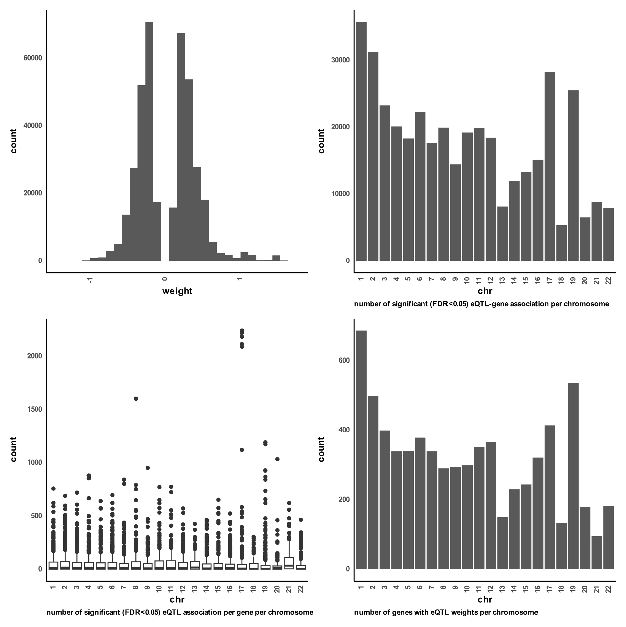

**Figure S 1 distributions of excitatory eQTL weights.**   
A) a histogram distribution of all significant (FDR < 0.05) gene-eQTL weights of all chromosomes. B) boxplot distribution of number of eQTL associations found per gene on each chromosome. C) boxplot for distribution of number of significant (FDR < 0.05) gene-eQTL associations per chromosome. D) distribution of number of unique genes found with significant (FDR < 0.05) gene-eQTL associations per chromosome.

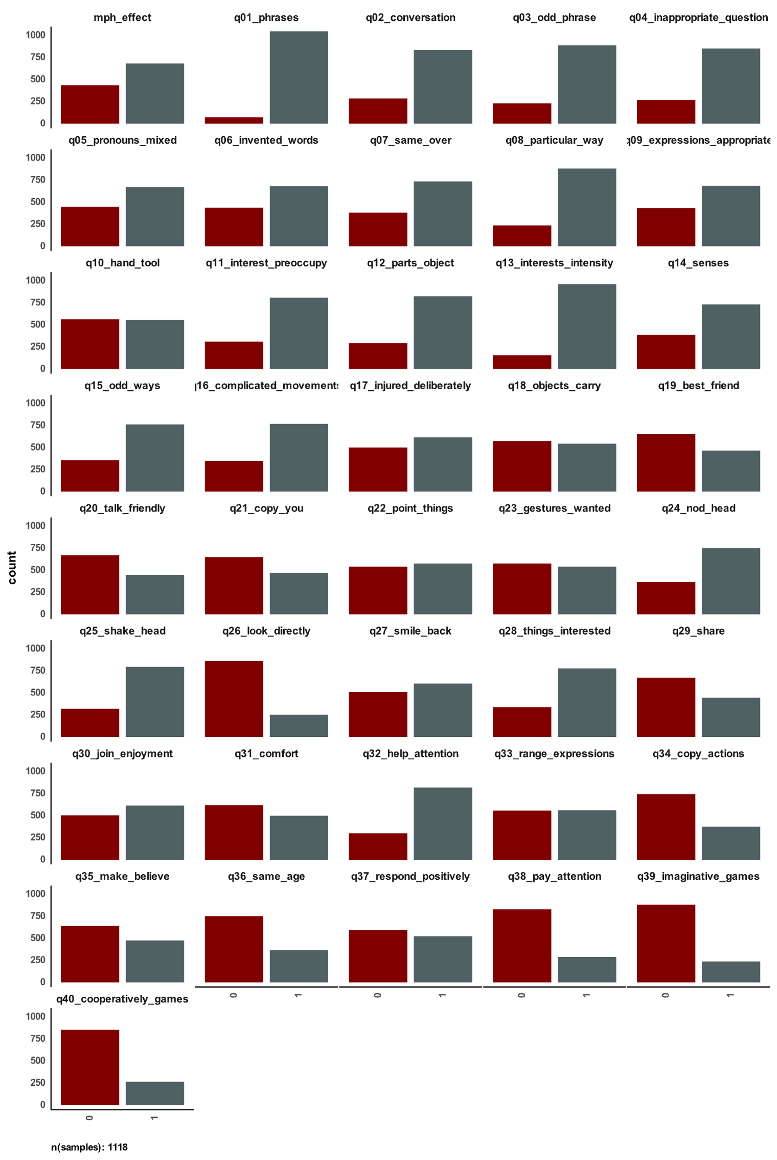

**Figure S 2 distribution of answers to social communication questionnaire in SPARK and used MPH effectiveness label.**   
The figure shows number of YES (=1) and NO (=0) answers per question in the social communication questionnaire for all samples with reported methylphenidate effectiveness.

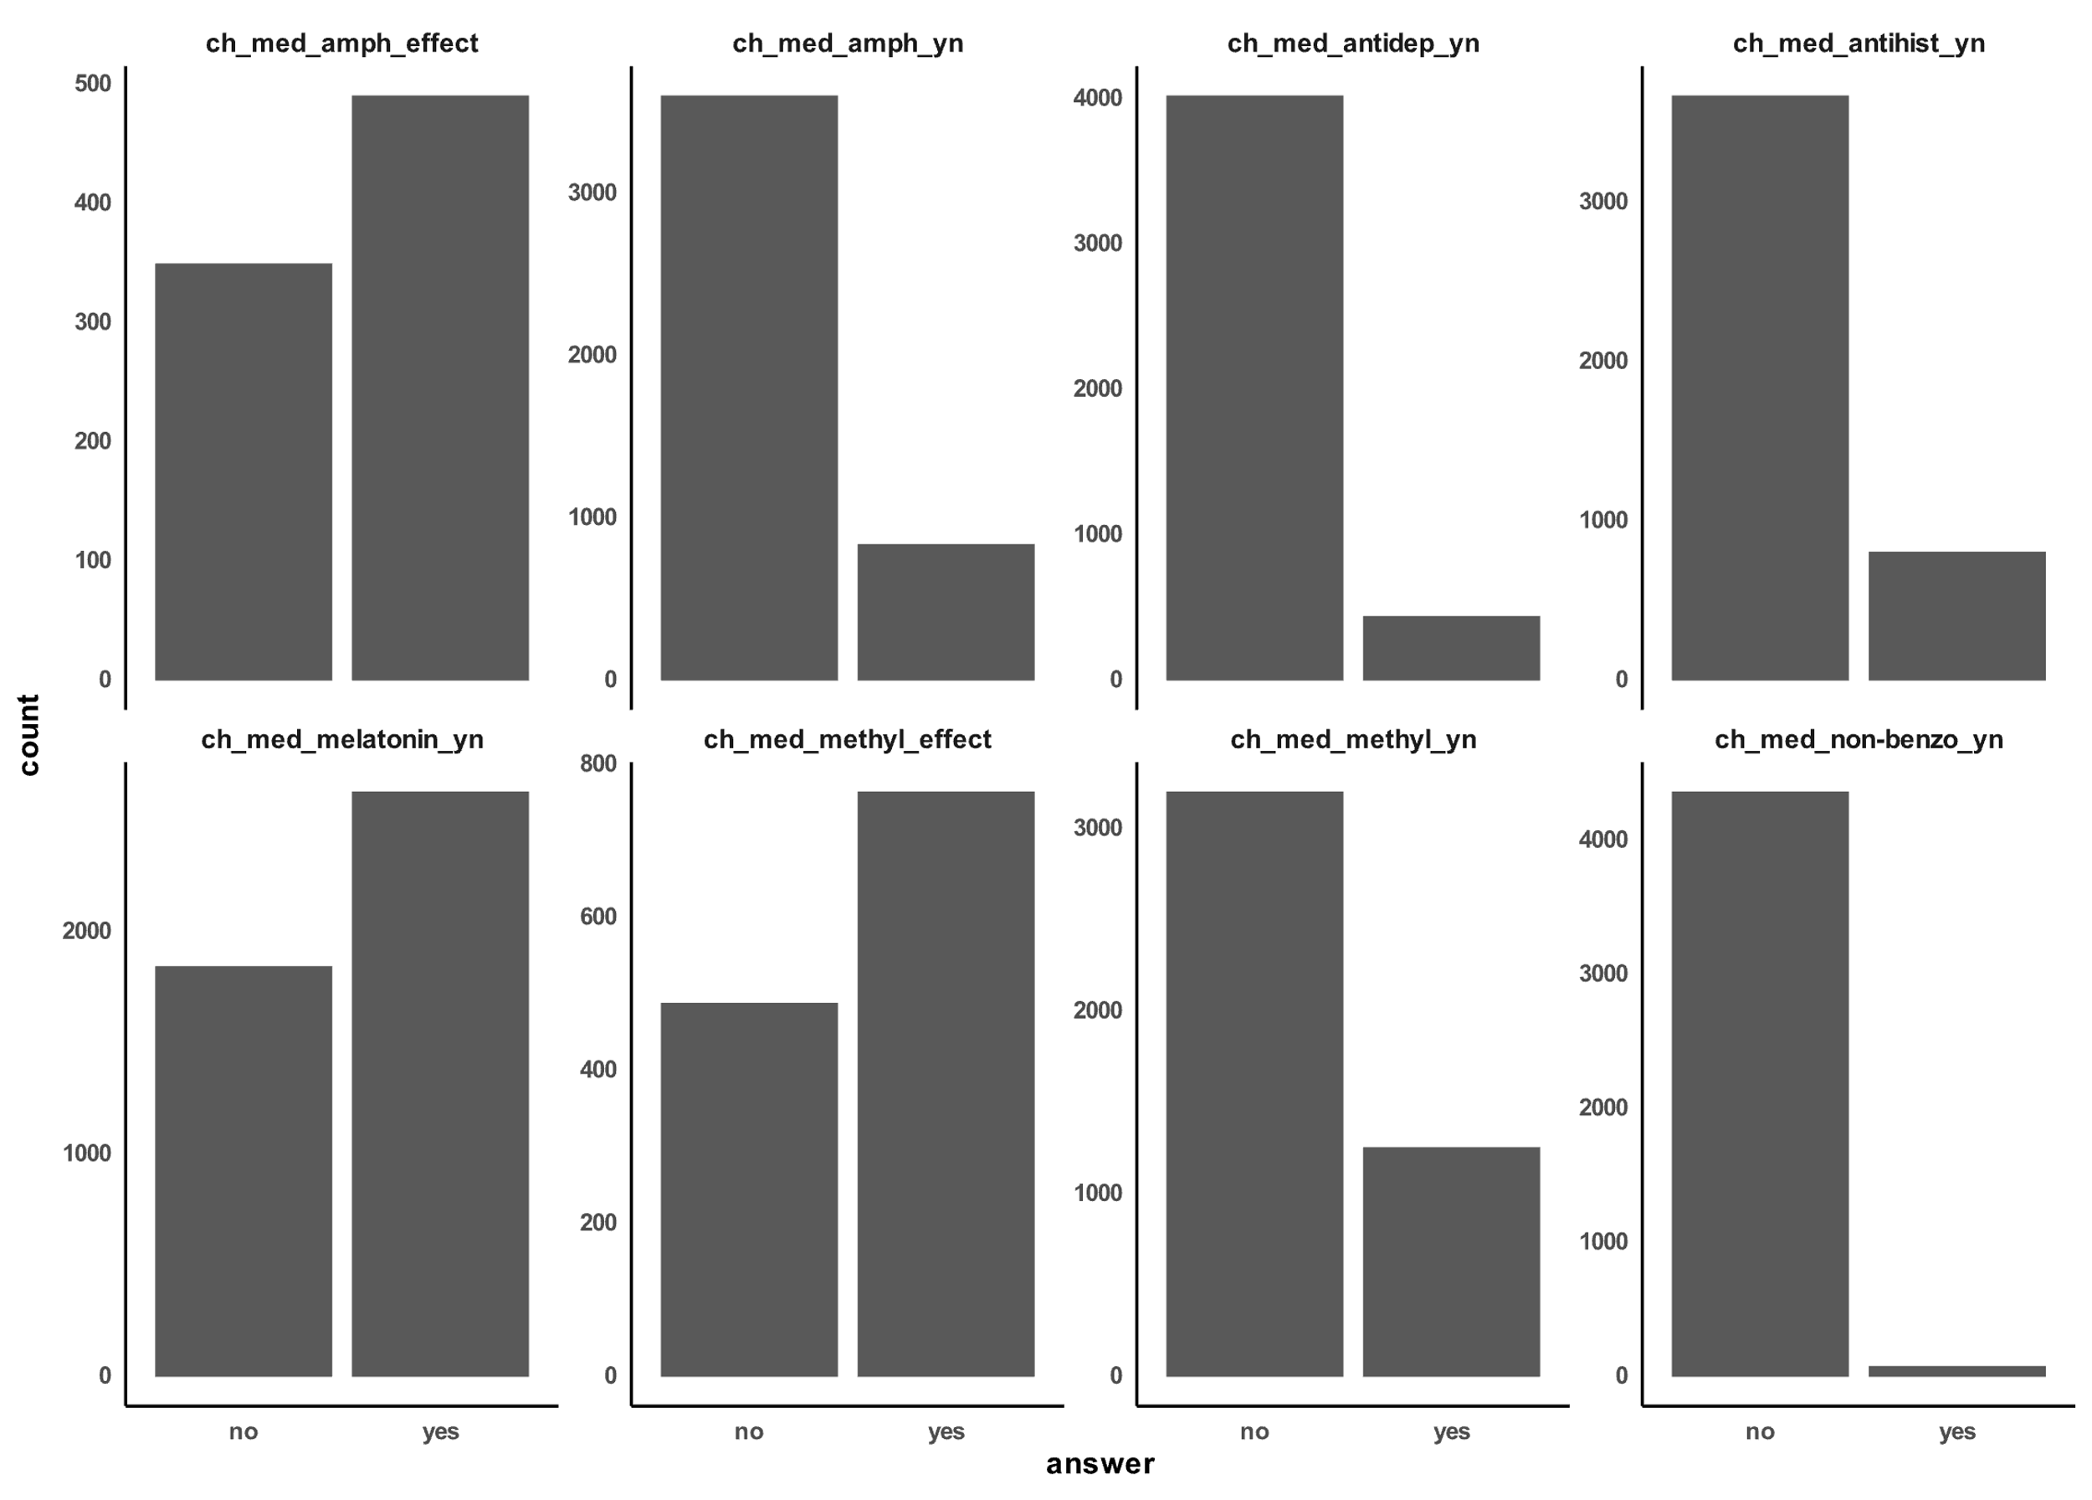

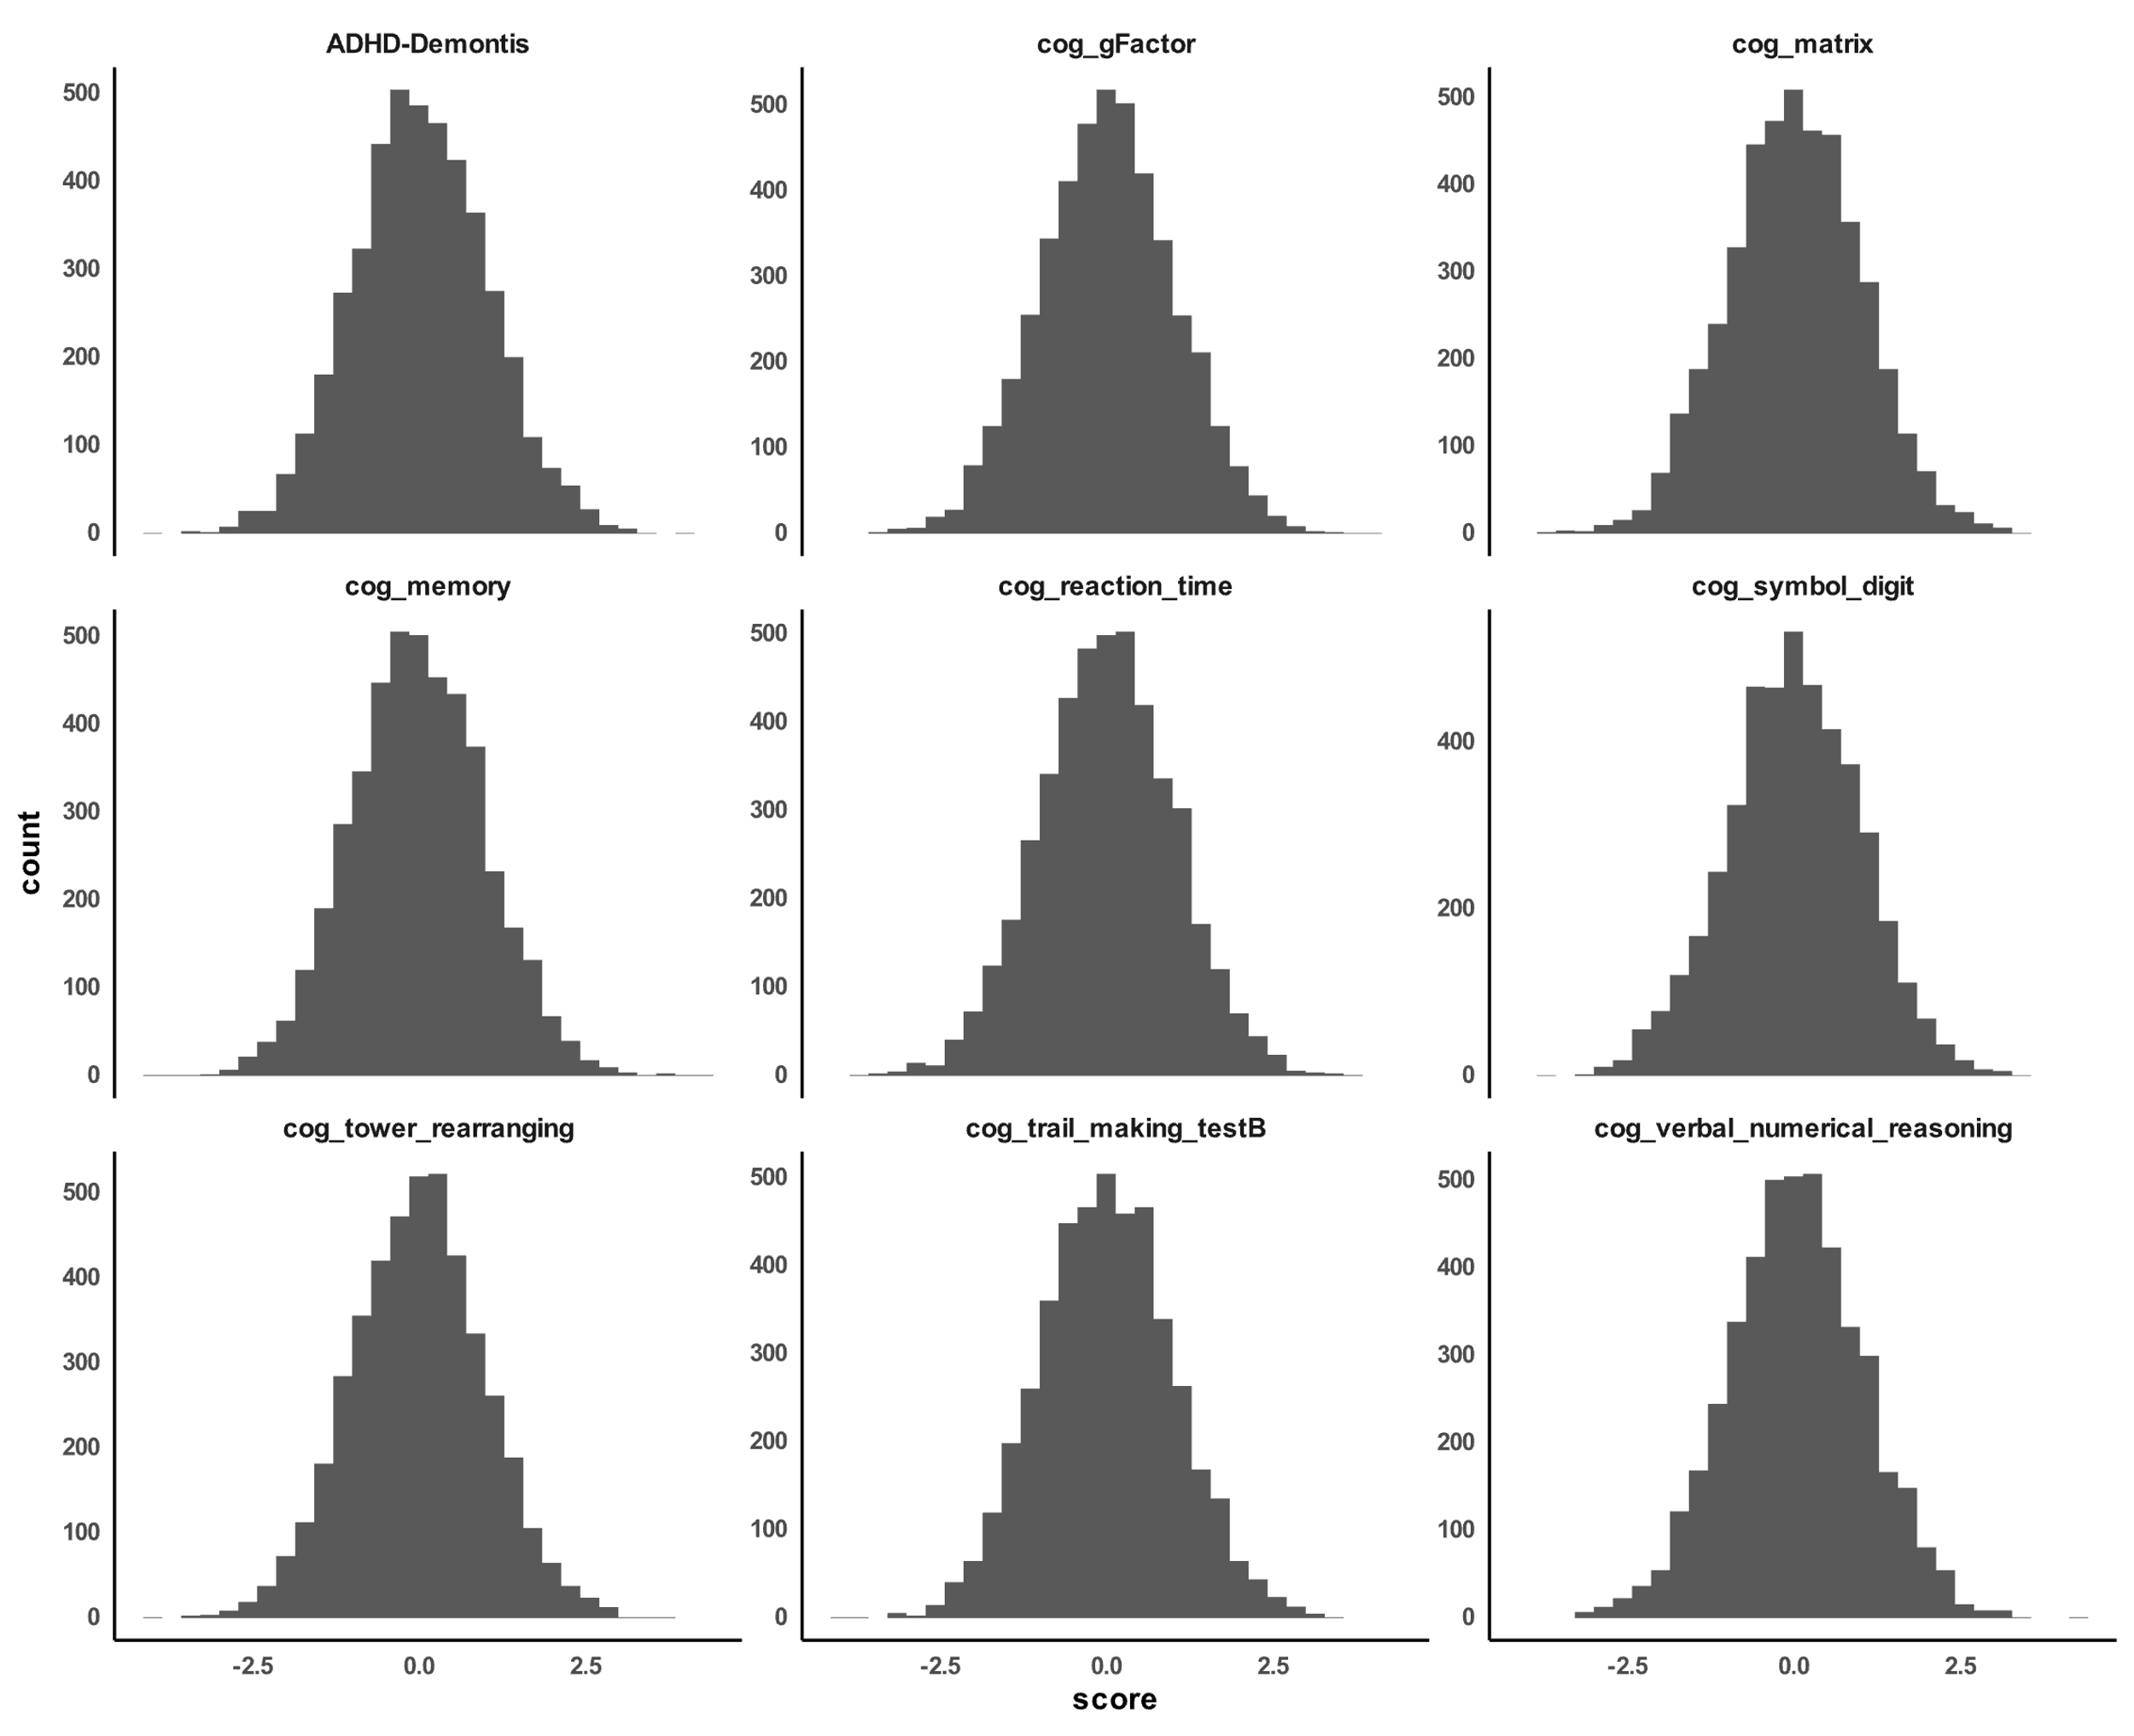

**Figure S 3 distribution of calculated polygenic scores for SPARK participants with reported methylphenidate effectiveness.**

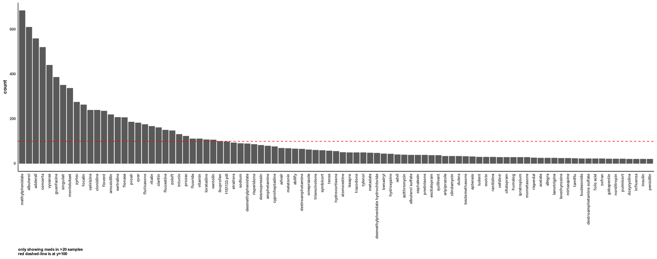

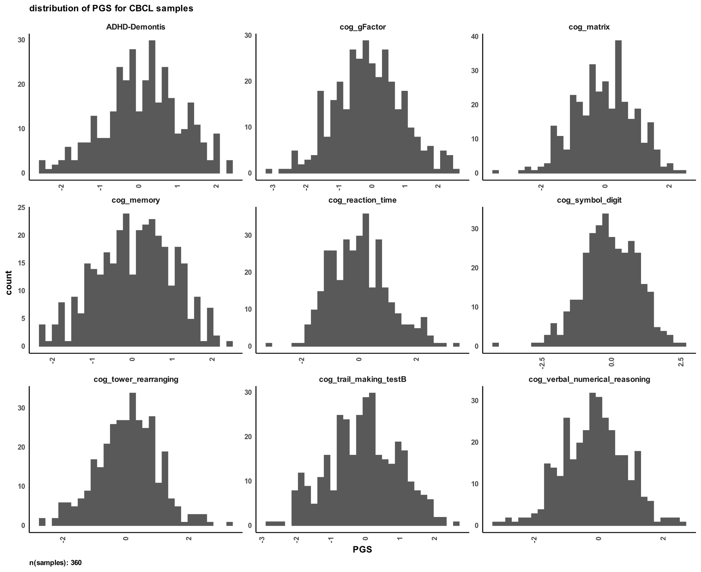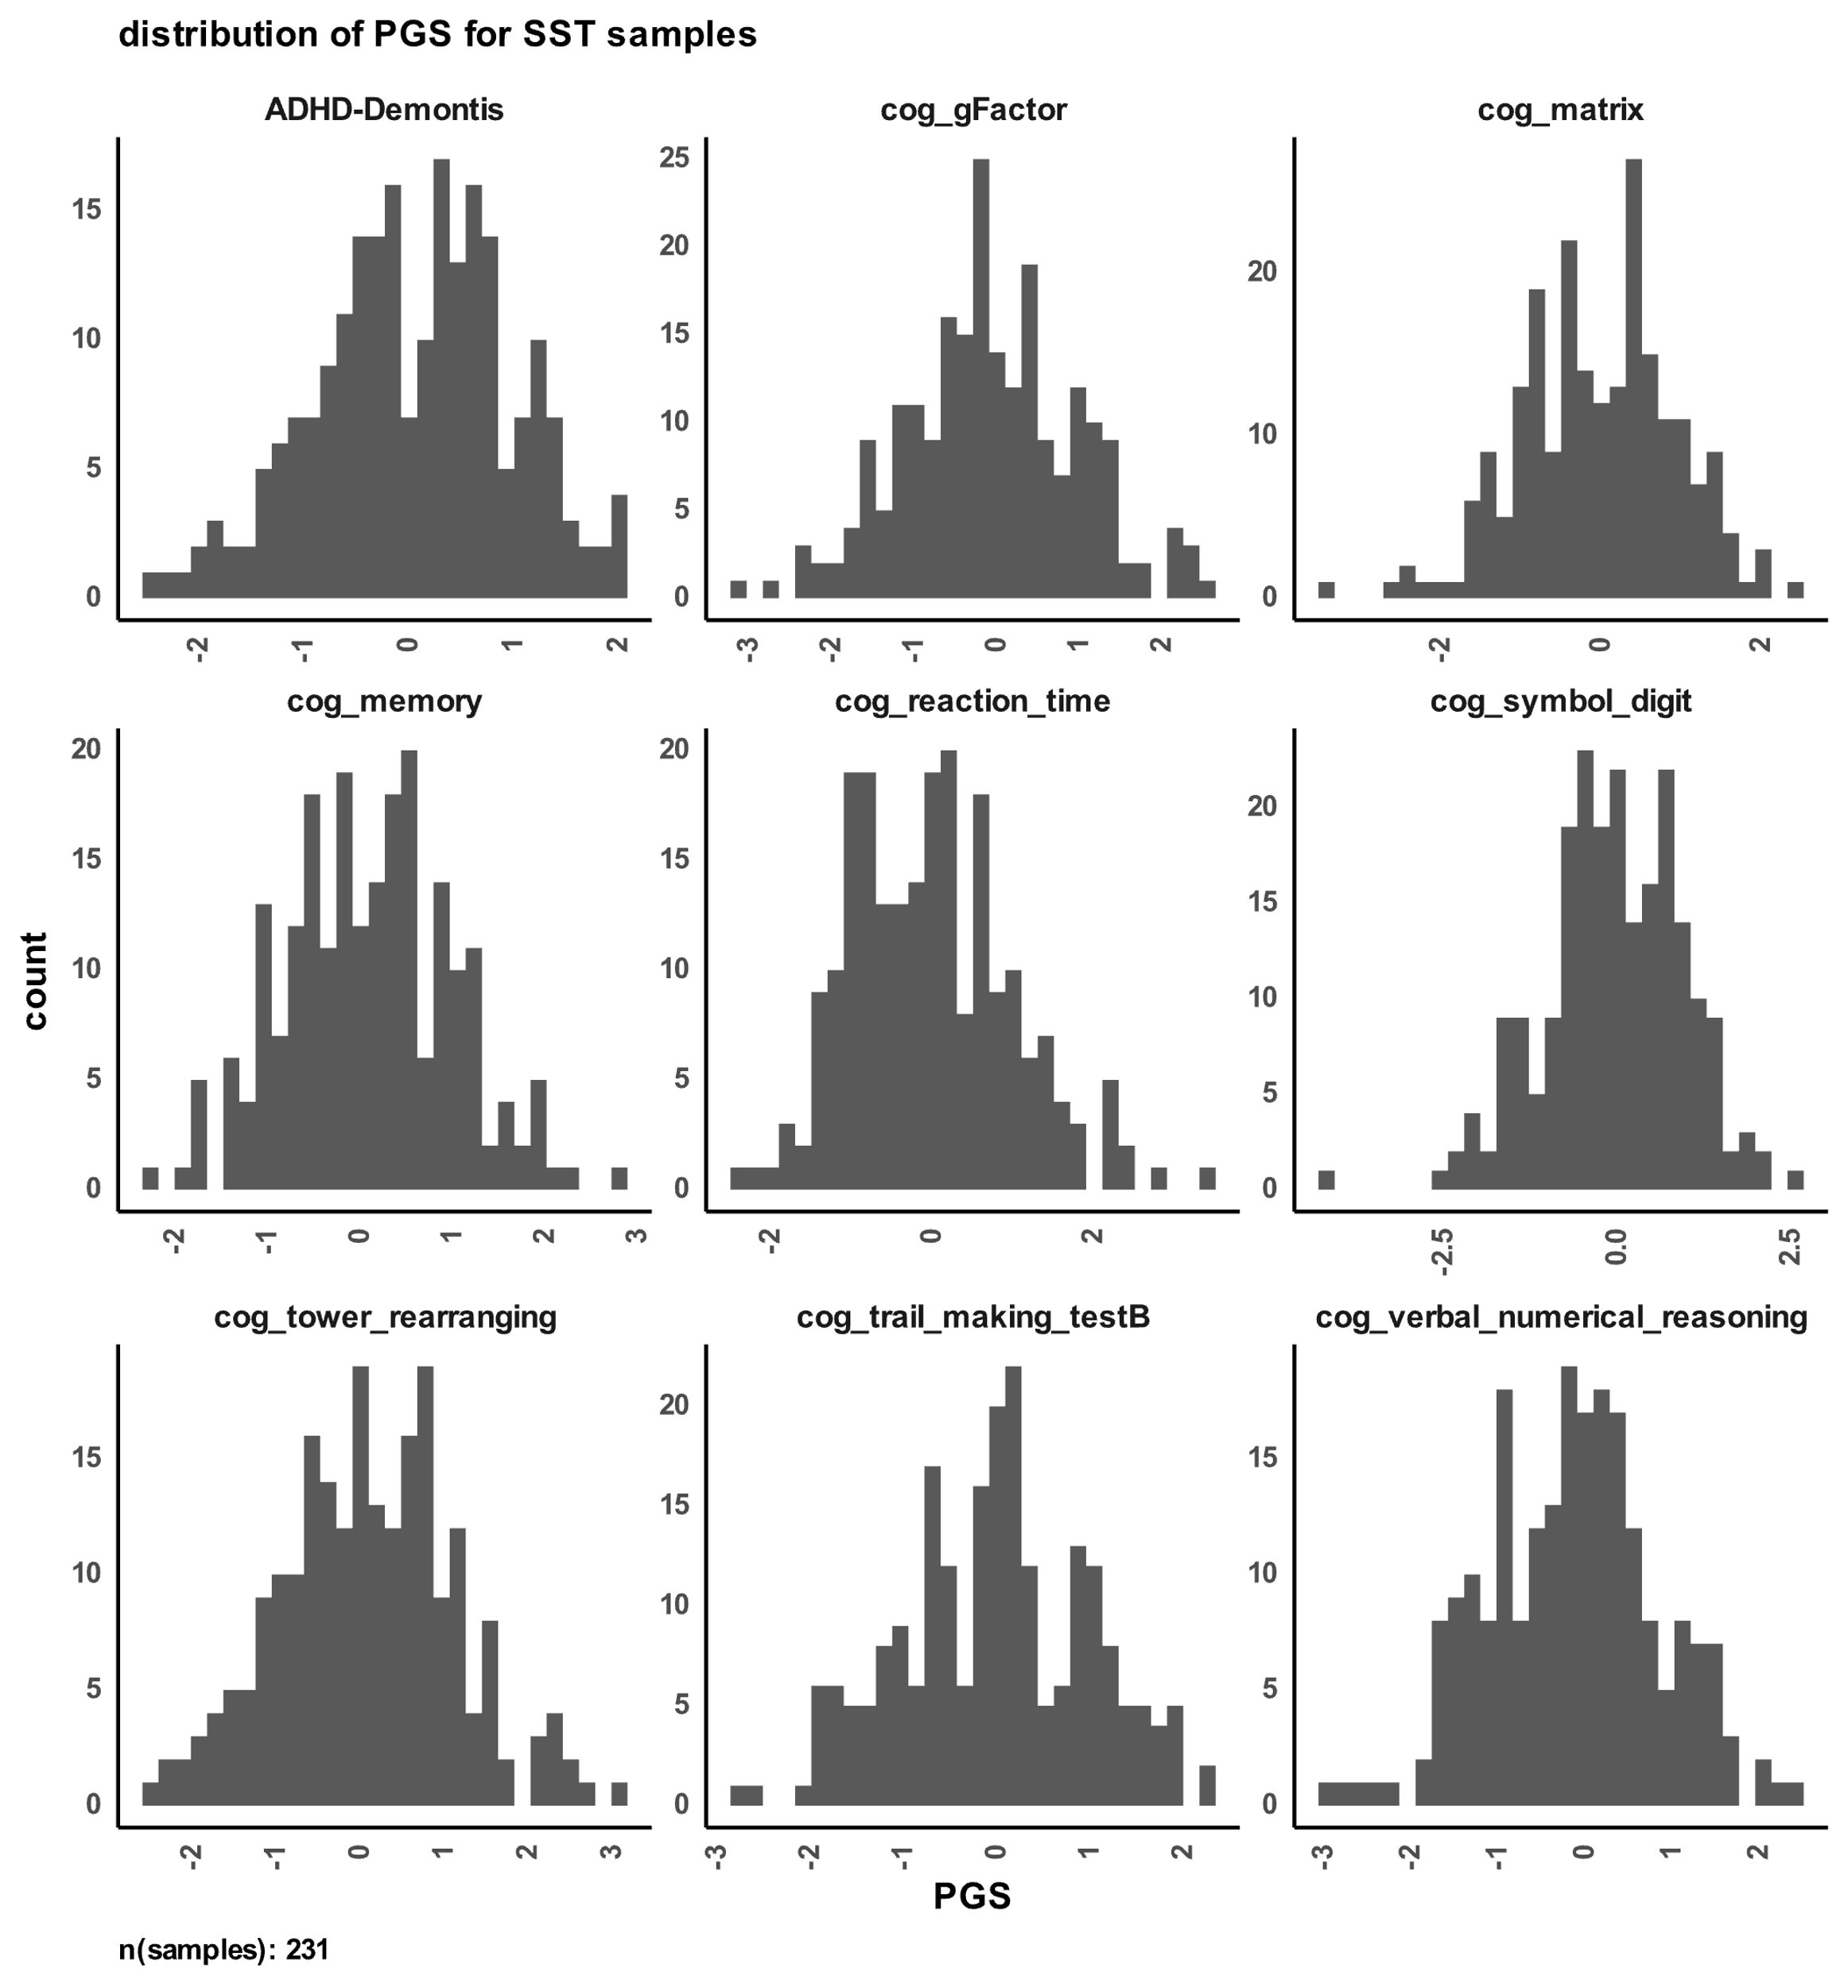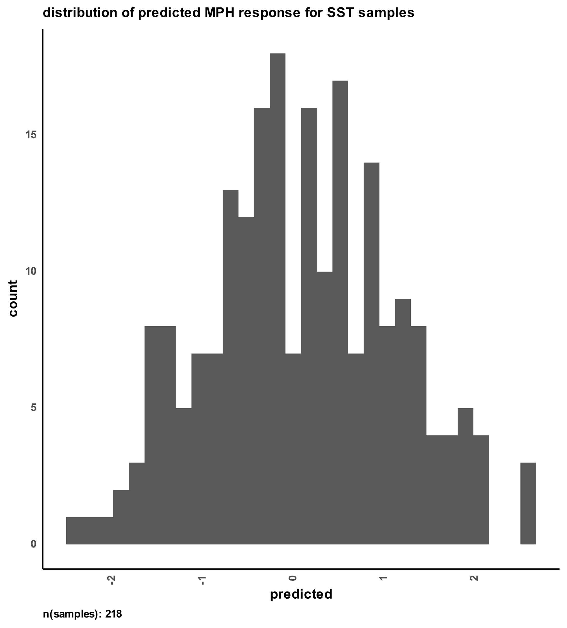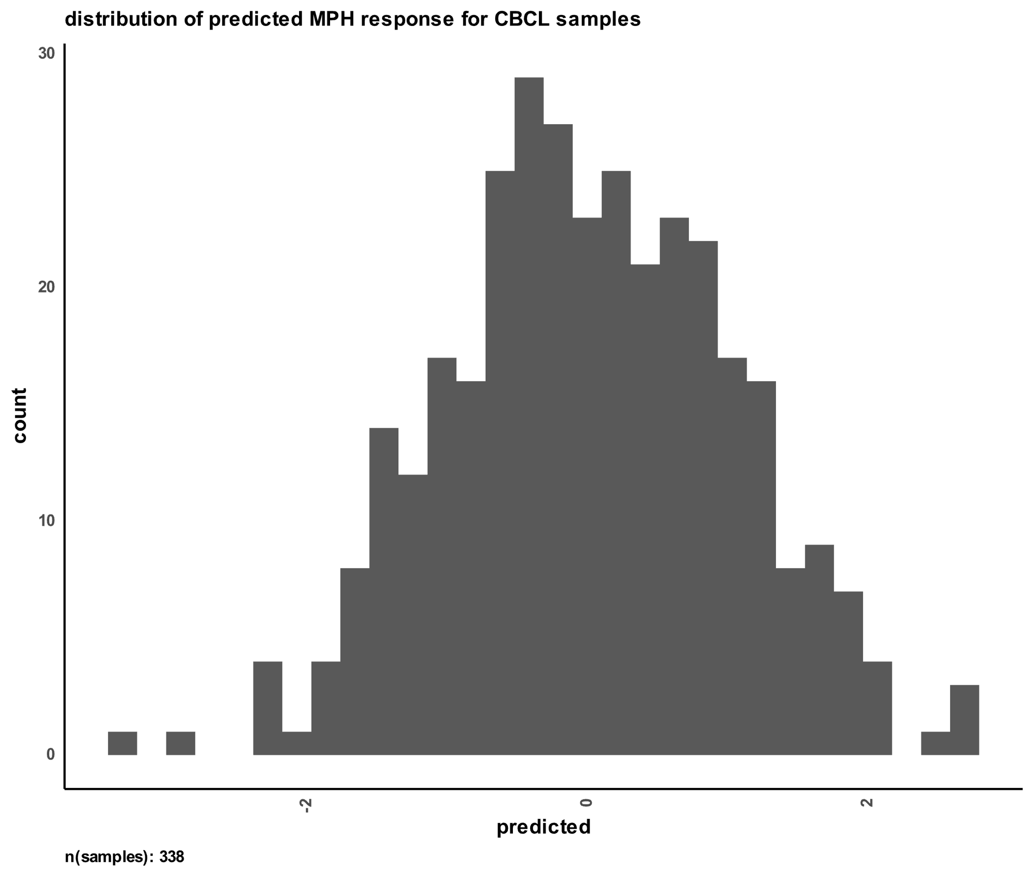

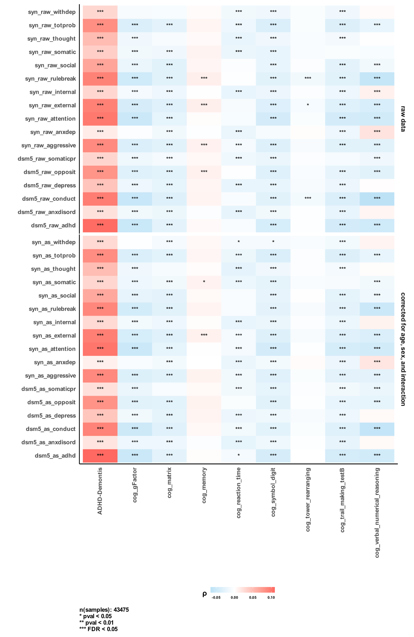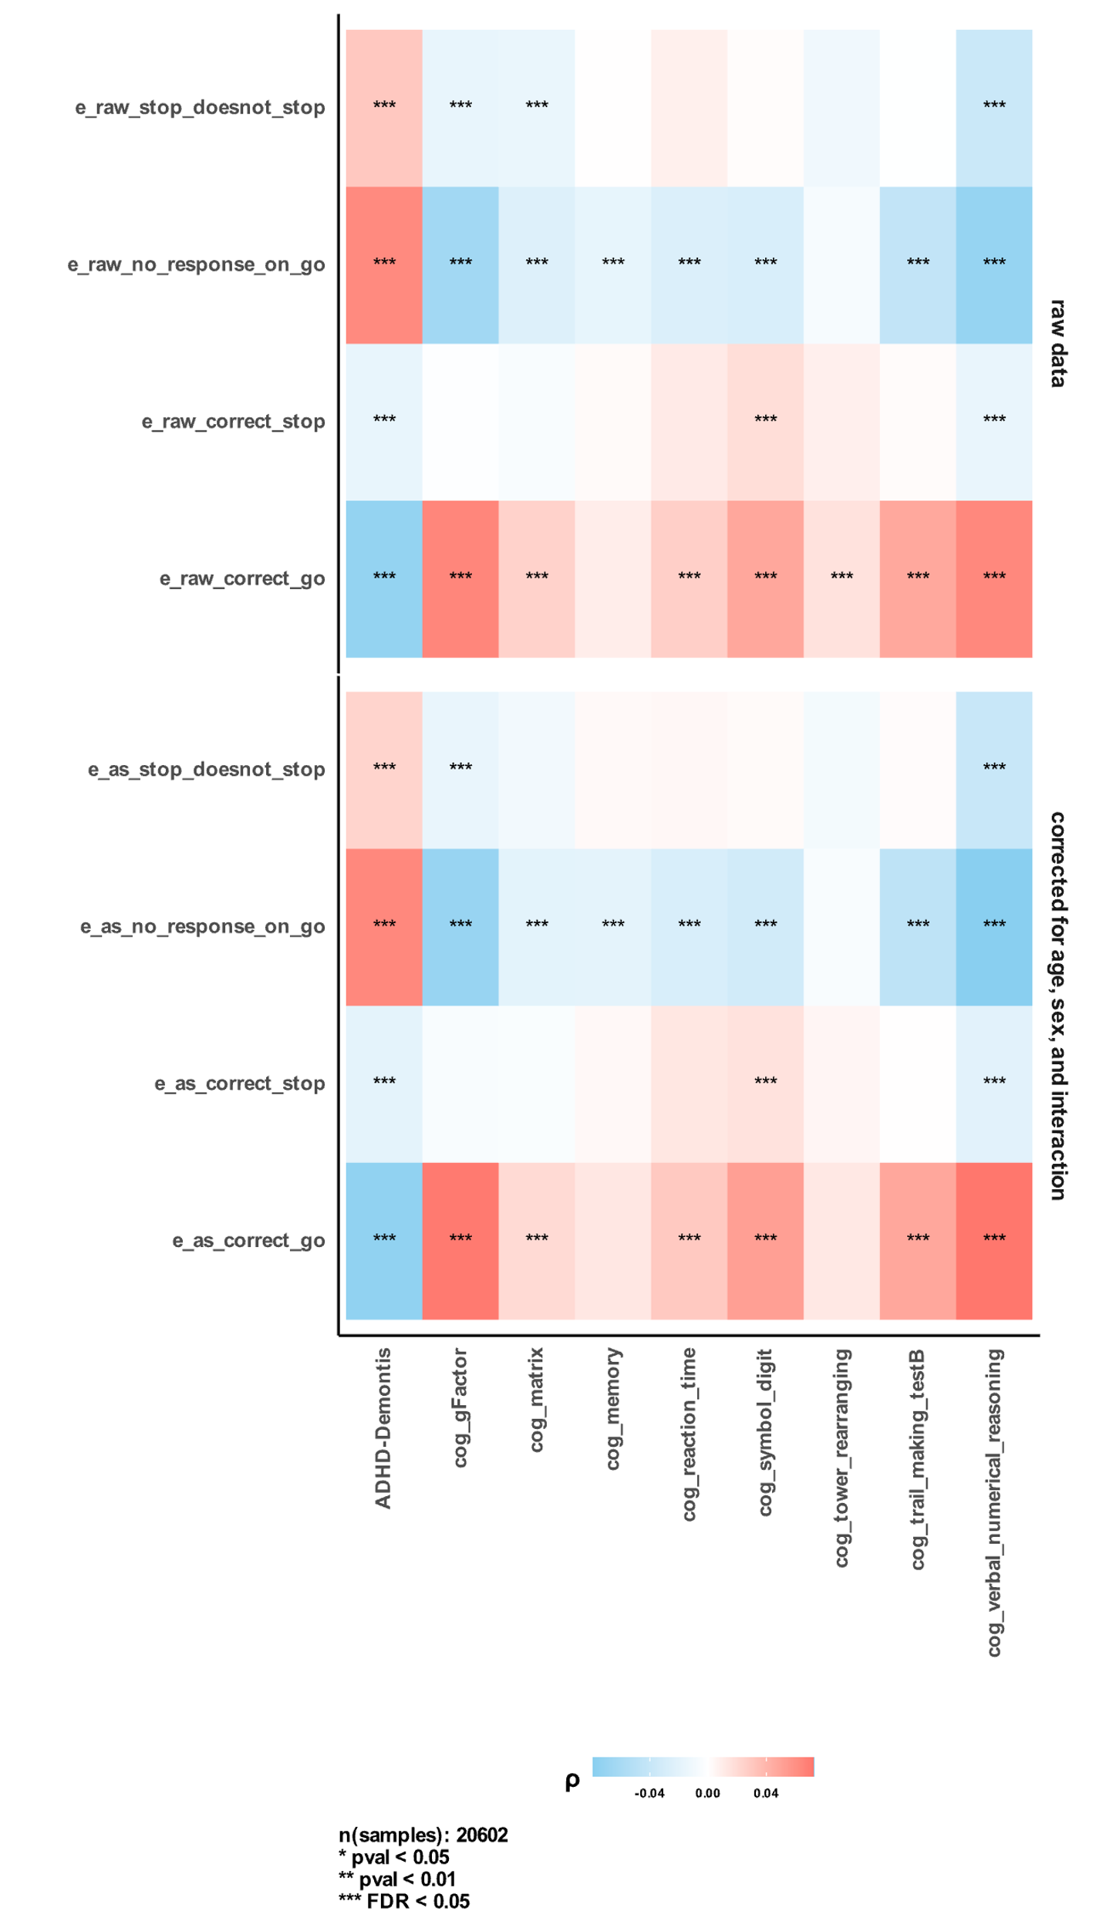

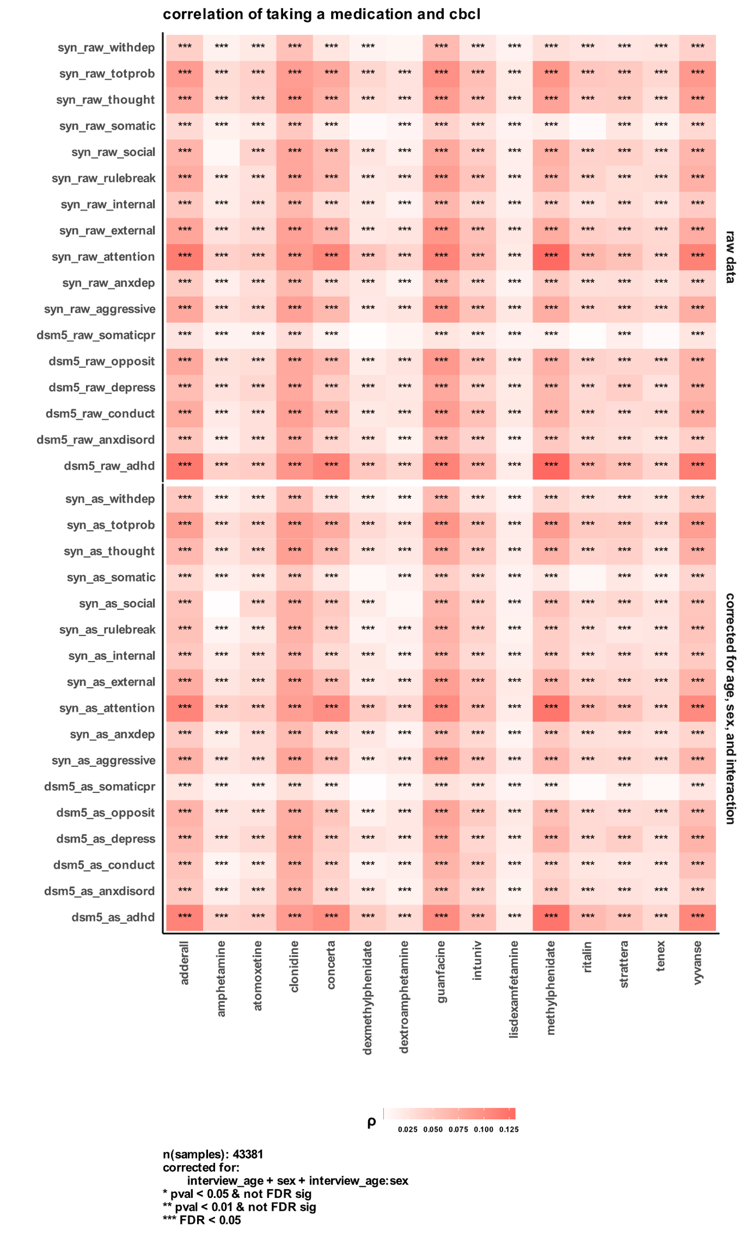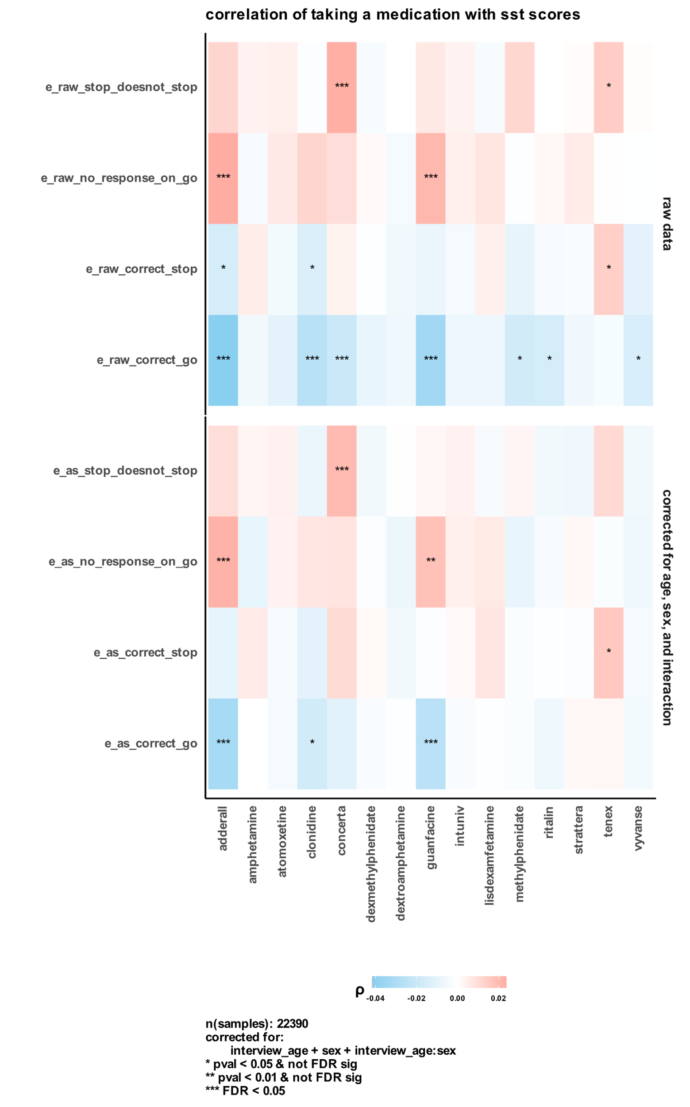

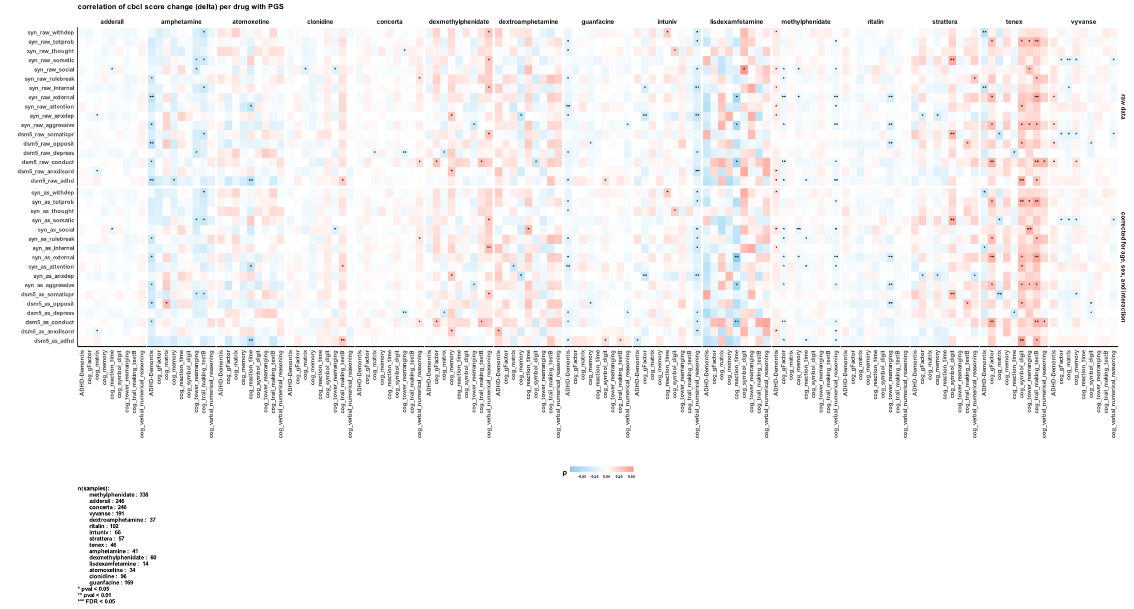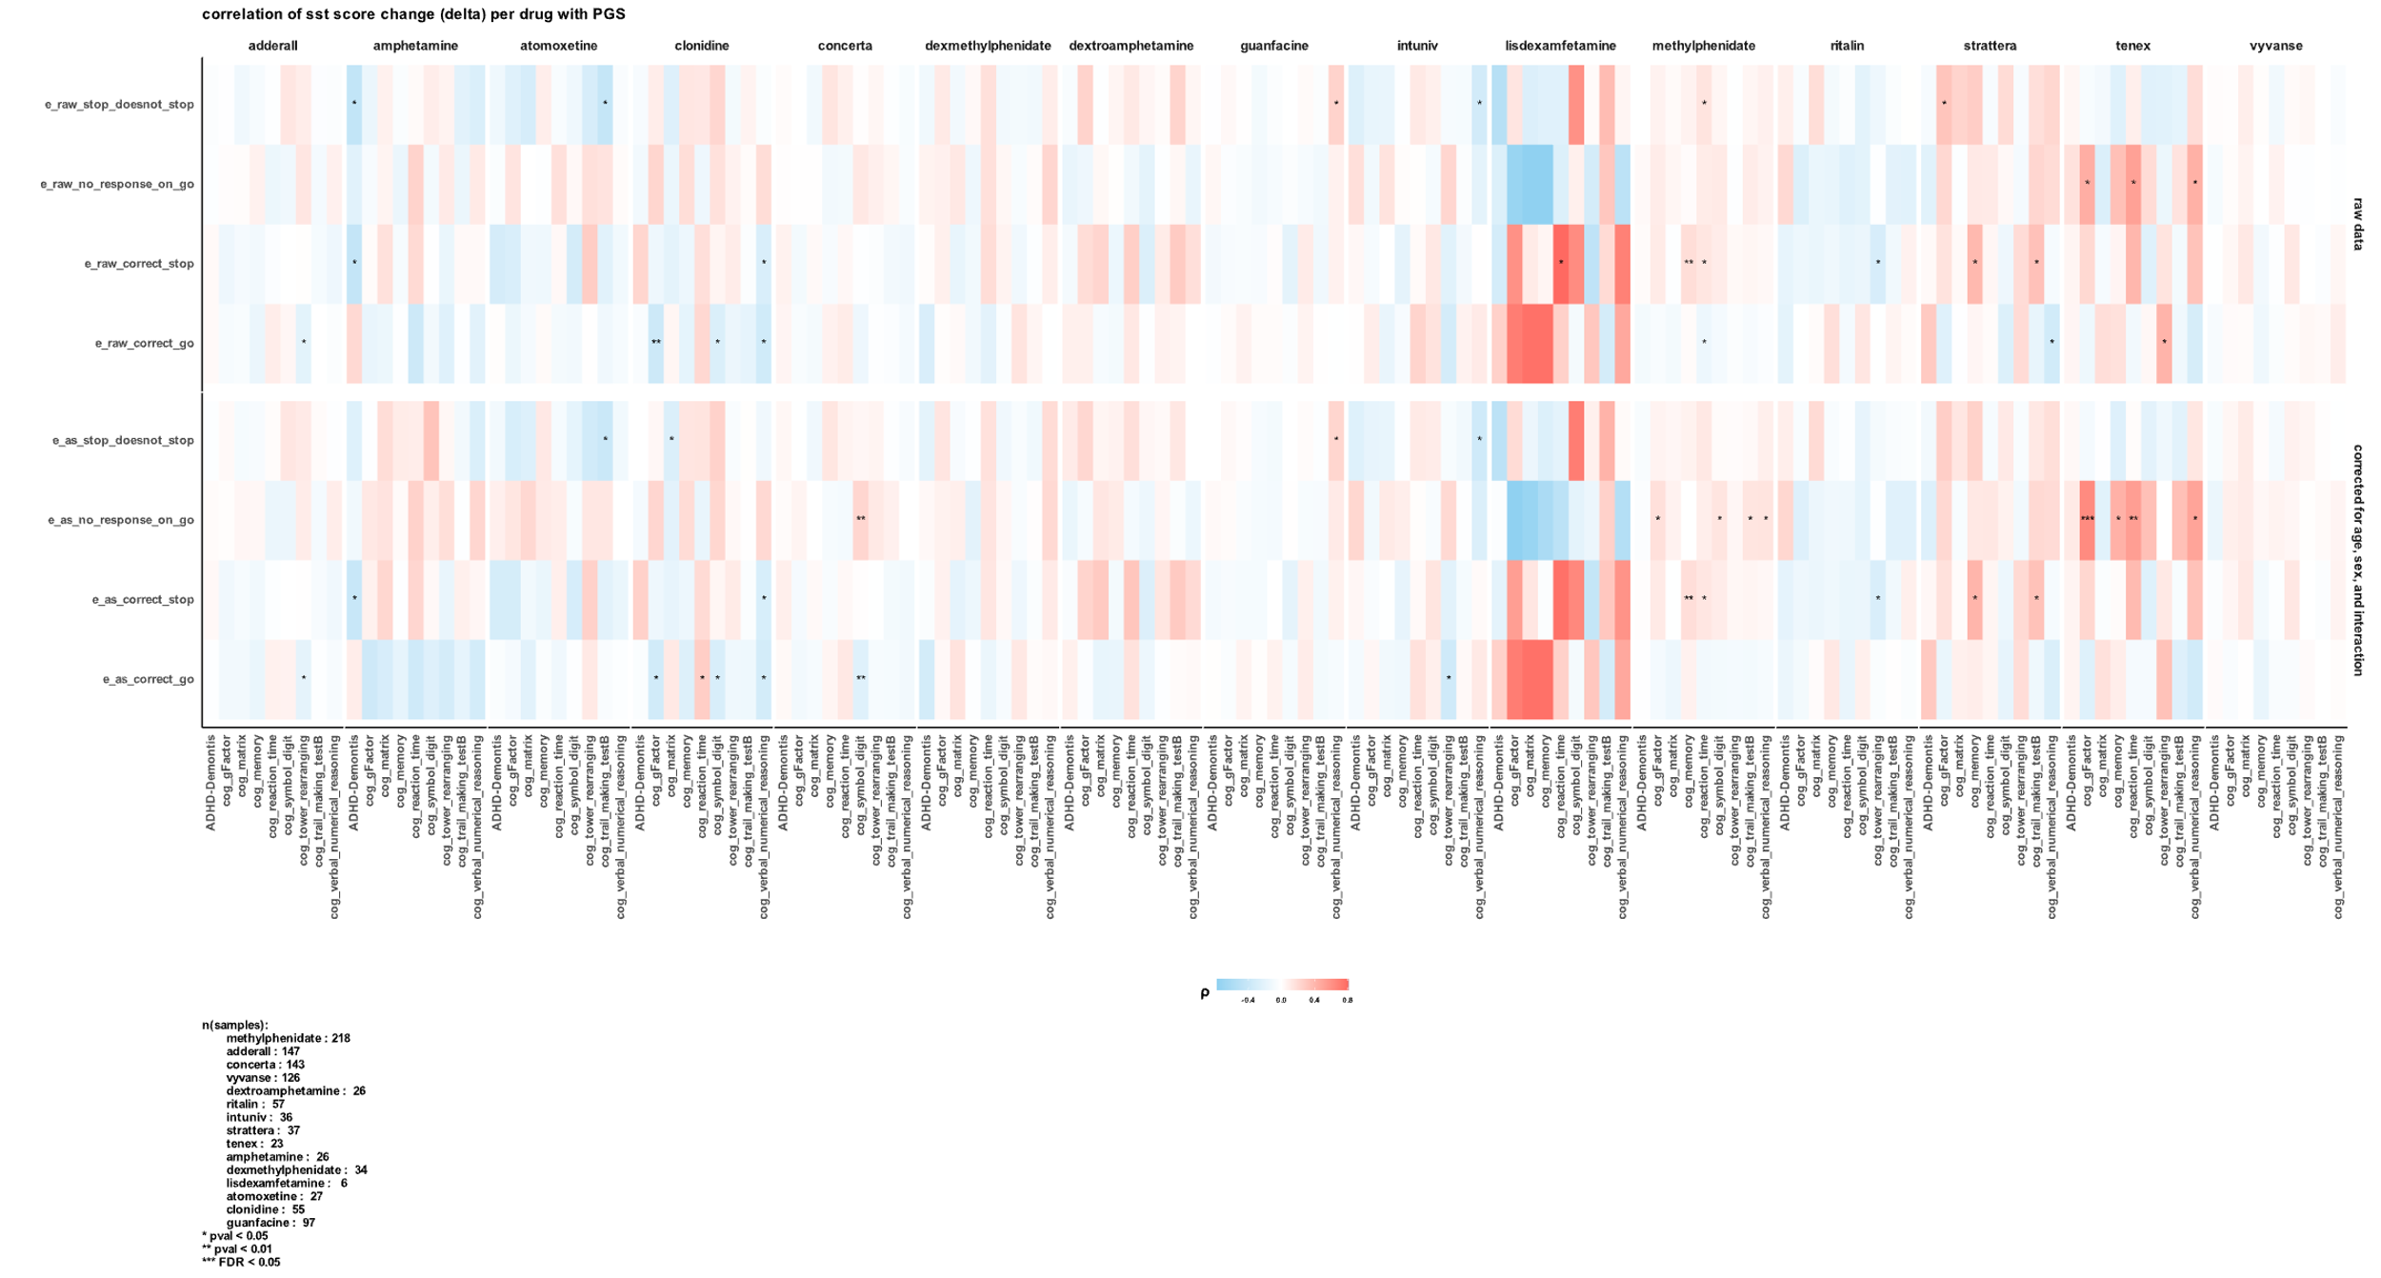

1. https://sparkforautism.org
2. https://abcdstudy.org
3. <https://www.broadinstitute.org/connectivity-map-cmap>